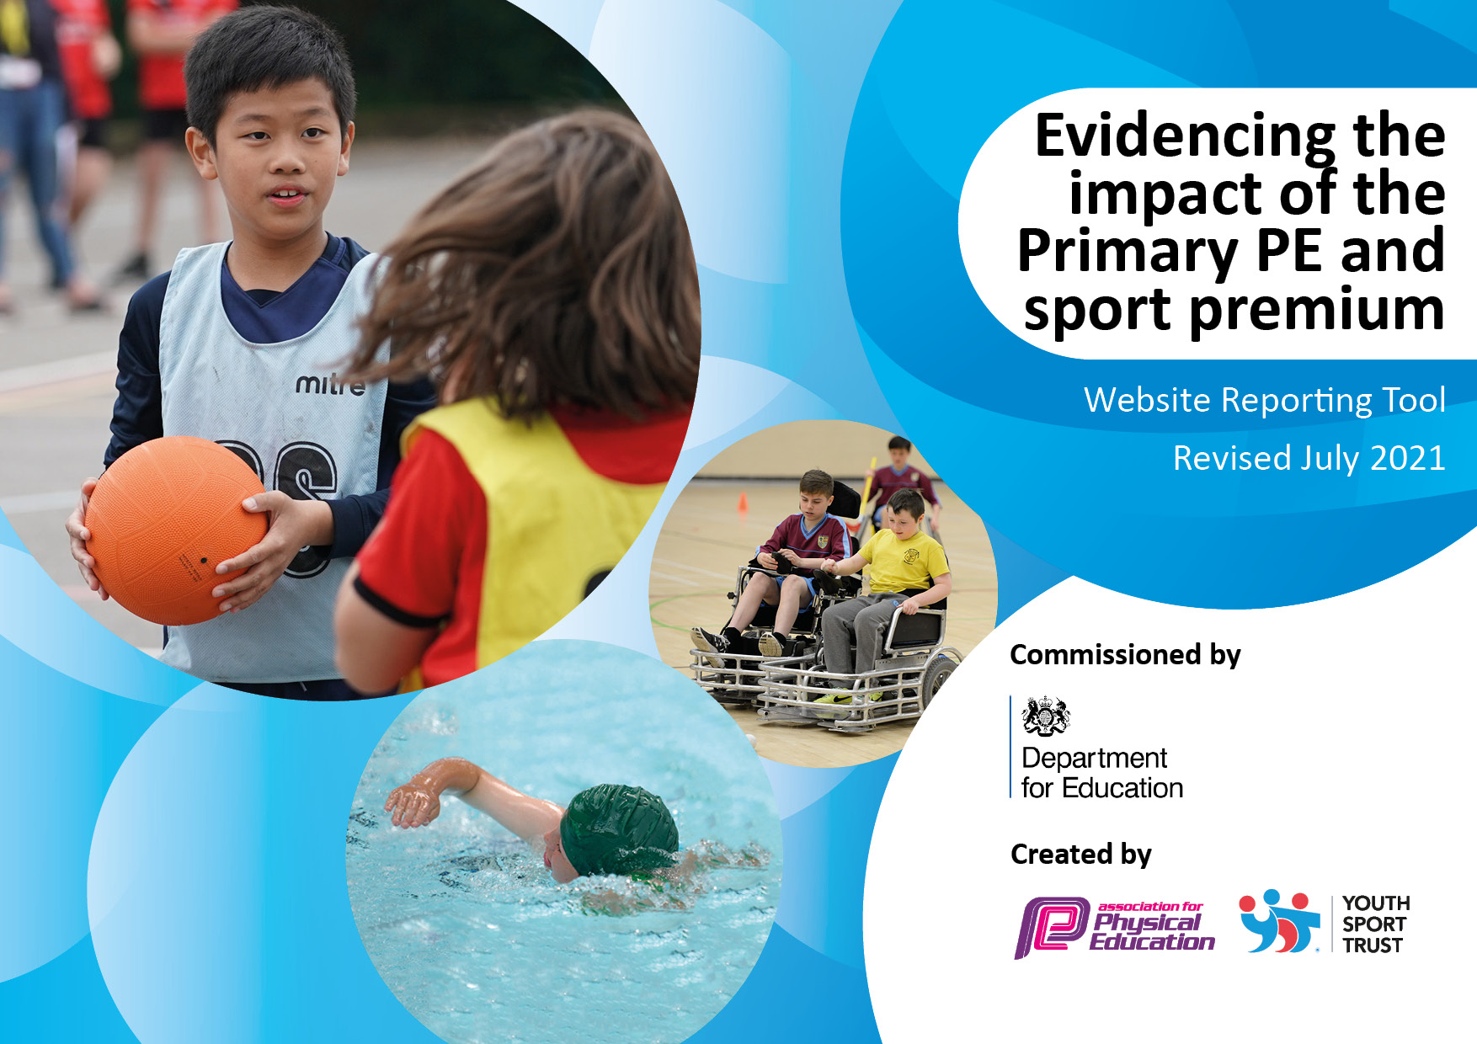
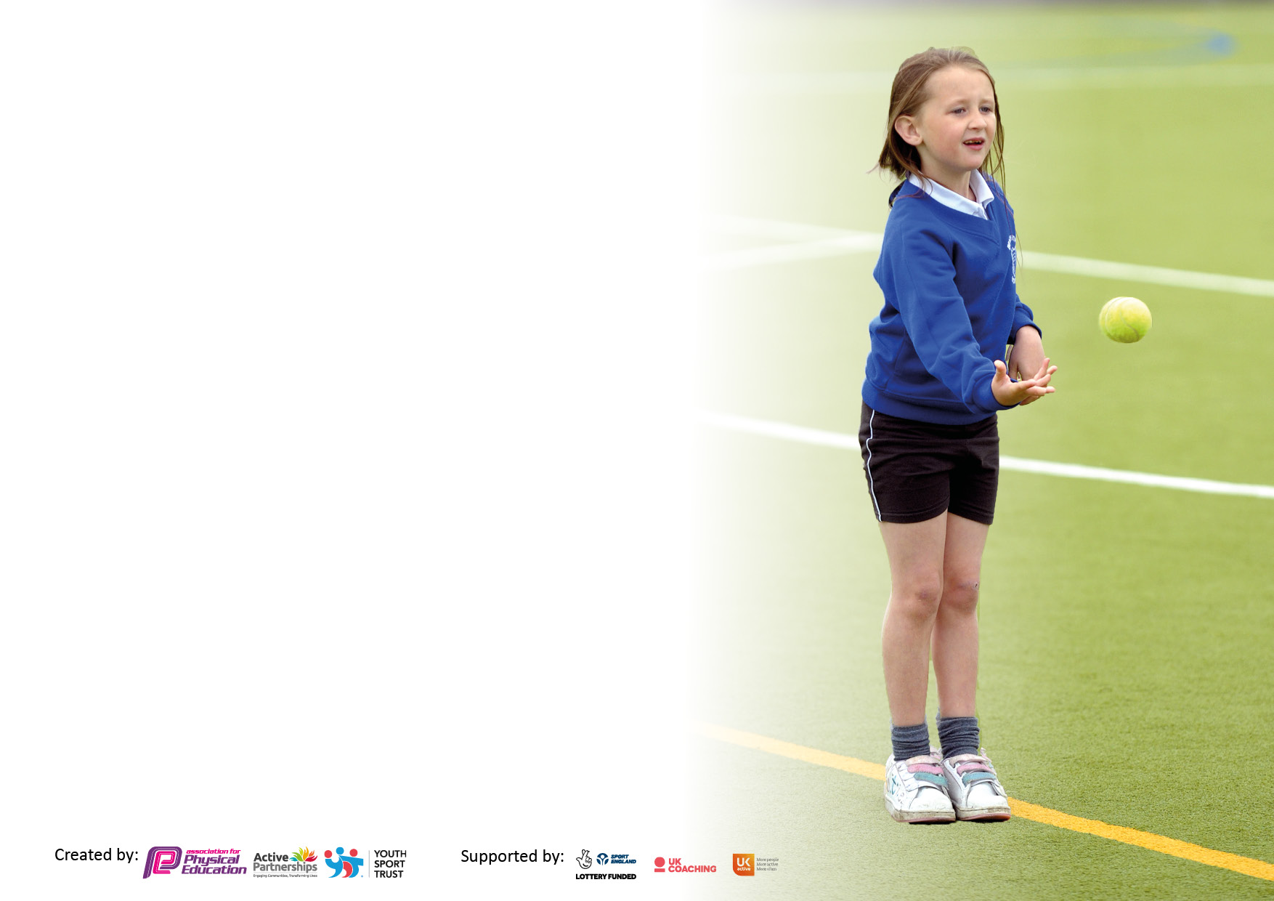

It is important that your grant is used effectively and based on school need. The Education Inspection Framework makes clear there will be a focus on ‘whether leaders and those responsible for governors all understand their respective roles and perform these in a way that enhances the effectiveness of the school’.

Under the Quality of Education Ofsted inspectors consider:
Intent - Curriculum design, coverage and appropriateness
Implementation - Curriculum delivery, Teaching (pedagogy) and Assessment
Impact - Attainment and progress

To assist schools with common transferable language this template has been developed to utilise the same three headings which should make your plans easily transferable between working documents.

Schools must use the funding to make additional and sustainable improvements to the quality of Physical Education, School Sport and Physical Activity (PESSPA) they offer. This means that you should use the Primary PE and sport premium to:

- Develop or add to the PESSPA activities that your school already offer
- Build capacity and capability within the school to ensure that improvements made now will benefit pupils joining the school in future years
- The Primary PE and sport premium should not be used to fund capital spend projects; the school’s budget should fund these.

Pleasevisitgov.ukfortherevisedDfEguidanceincludingthe5keyindicatorsacrosswhichschoolsshoulddemonstrate animprovement.Thisdocumentwillhelpyoutoreviewyourprovisionandtoreportyourspend.DfEencouragesschools to use this template as an effective way of meeting the reporting requirements of the Primary PE and sport premium.

We recommend you start by reflecting on the impact of current provision and reviewing the previous spend.

Schools are required to publish details of how they spend this funding, including any under-spend from 2019/2020, as well as on the impact it has on pupils’ PE and sport participation and attainment. All funding must be spent by 31st July 2022.

We recommend regularly updating the table and publishing it on your website throughout the year. This evidences your ongoing self-evaluation of how you are using the funding to secure maximum, sustainable impact. Final copy must be posted on your website by the end of the academic year and no later than the 31st July 2021. To see an example of how to complete the table please click HERE.
Created by: Supported by:

Details with regard to funding
Please complete the table below.

Total amount carried over from 2019/20 | £
Total amount allocated for 2020/21
How much (if any) do you intend to carry over from this total fund into 2021/22? | £2,466
Total amount allocated for 2021/22 | £16,960
Total amount of funding for 2021/22. To be spent and reported on by 31st July 2022. | £19,426.00
Swimming Data
Please report on your Swimming Data below.

Meeting national curriculum requirements for swimming and water safety.  N.B. Complete this section to your best ability. For example you might have practised safe self-rescue techniques on dry land which you can then transfer to the pool when school swimming restarts.  Due to exceptional circumstances priority should be given to ensuring that pupils can perform safe self rescue even if they do not fully meet the first two requirements of the NC programme of study | N/A
What percentage of your current Year 6 cohort swim competently, confidently and proficiently over a distance of at least 25 metres?  N.B. Even though your pupils may swim in another year please report on their attainment on leaving primary school at the end of the summer term 2020.  Please see note above | % N/A
What percentage of your current Year 6 cohort use a range of strokes effectively [for example, front crawl, backstroke and breaststroke]?  Please see note above | % N/A
What percentage of your current Year 6 cohort perform safe self-rescue in different water-based situations? | % N/A
Schools can choose to use the Primary PE and sport premium to provide additional provision for swimming but this must be for activity over and above the national curriculum requirements. Have you used it in this way? | N/A

Action Plan and Budget Tracking
Capture your intended annual spend against the 5 key indicators. Clarify the success criteria and evidence of impact that you intend to measure to evaluate for pupils today and for the future.

Academic Year: 2020/21 | Total fund allocated: | Date Updated:
Key indicator 1: The engagement of all pupils in regular physical activity – Chief Medical Officers guidelines recommend that primary school pupils undertake at least 30 minutes of physical activity a day in school |  |  |  | Percentage of total allocation:
 |  |  |  | %
Intent | Implementation |  | Impact | £6483.36
Your school focus should be clear what you want the pupils to know and be able to do and about  what they need to learn and to  consolidate through practice: | Make sure your actions to achieve are linked to your intentions: | Funding allocated: | Evidence of impact: what do pupils now know and what can they now do? What has changed?: | Sustainability and suggested next steps:
Continue to embed Children’s health, mental health and wellbeing project scheme of work in line with PSHE.  Particular focus on oral health-  Lunch provision  Interactive display in the hall.  Encourage children who attend sports clubs outside of school to share their photos, giving all children the chance to celebrate the opportunities both in and outside school over the year.  WOW-Living Streets – travel Tracker-Encouraging more children to walk or park and stride to school. Children to be encouraged to come to school on their scooters.  Re- Join Yorkshire Sports Foundation  Scooter fit  Scooter Fit Training | New children starting in school and continuing to embed with older children-ensure worked into curriculum in line with health and relationship curriculum. PSHE lead ELSA and PE lead to continue to work together. Assemblies and circle time on importance of oral health. Tooth brush for every child in school.  Sports/play leader in each year group actively encouraging children to take part in in lunchtime games and activities, facilitating fitness, sports and games. Encouraging safe play.  Encourage class teachers to share photos and to catch the children’s voice, in a way that ensures that all children want to engage and stay engaged in physical activity. Share in good work assembles  Ensure that children’s voice is part of this display. Photographs’ of children partaking activities outside School-Class teachers to send to PE lead  Launch assembly- living streets team meeting with parents encouraging the parents and children to walk to school, enhancing the children’s 30 minutes of further exercise per day. Children can win badges if the walk or park stride, scooter at least three times per week.  Use resources, ideas in extracurricular activities/pupil questionnaires  Taster session in school.  One of the teaching staff to train for 1 day  Buy six scooters for Nursery children and one adult scooter-Emma to lead session with Nursery and reception children | £130.00  £6,078  £55  £220-  £360 | Baseline and beginning and end of year, to demonstrate the children’s understanding of health and fitness and the impact of wellbeing. Children will have a better understanding of oral hygiene  Children to get dojos for taking part in new games and encouraging other children to take part. Certificates for good sporting ethics- praising winners, being a good loser.  Interactive display that encourages children to discuss physical education and keeping healthy. For children to want to try different types of sports education- dance, gymnastics, PE and athletics  Children are trying so hard to ensure that they walk, scooter to school or park and stride. Even when the weather was bad.  We are working with the Local Council and MP to see how we can make it even safer for the children to scooter to school. We took part in an audit with Living Streets and looked at pavement safety- cars parked on pavement.  Use of surveys and extracurricular activities throughout the year  All children from Nursery up to year two took part in a short taster session-  E.De’Ath now trained teacher in scooter fit- we have bought scooters for Nursery/ Reception children to use. | Children have a clearer understanding of why the need to clean their teeth and how to keep a healthy body. Drop in number of children going to the dentist for fillings.  Sports leaders are encouraging the children to be more active at lunchtime- increased interest in sport- pupil surveys, more of the children’s voice into what else we can offer at lunchtimes  Board in place, we need to capture more of the pupil voice, class teacher to add pupil voice and share on one drive.  More children walking, scootering or park and stride to school, over 50% children in the summer term. Continue next academic year invite Nursery children to join. Children are motivated and discuss with their classmates.  Able to capture children’s voice, children requesting tennis, hockey and basketball after school club  This resulted in getting one of teaching staff to become trained in teaching scooter fit.  We would like to run this throughout school. Start with Nursery & Reception Summer 2
Key indicator 2: The profile of PESSPA being raised across the school as a tool for whole school improvement |  |  |  | Percentage of total allocation:
 |  |  |  | %
Intent | Implementation |  | Impact | £350- for athletes to visit
Your school focus should be clear what you want the pupils to know and be able to do and about  what they need to learn and to  consolidate through practice: | Make sure your actions to achieve are linked to your intentions: | Funding allocated: | Evidence of impact: what do pupils now know and what can they now do? What has changed?: | Sustainability and suggested next steps:
Children’s Health project- scheme of work in line with PSHE.  Role models and local sporting heroes to be invited into school cricketers and athletes into school-women footballers and cricketers  Celebration Assembly to ensure that the whole school is aware of the importance of PE & Sport- help to encourage all pupils to aspire to being involved in the assemblies | Teachers to continue to embed the scheme of work into daily curriculum, in line with new health and relationships curriculum. PSHE lead and PE leads to work together to establish Healthy mind, healthy body week. Assembly about good oral hygiene being part of healthy mind and body.  To take place summer 2 to coincide with sports day.  Whole school assembly- where athlete shares their journey with the children.  Children to research named athletes and try and compete in their sport.  Member of England’s hockey team to lead an assembly.  Achievements celebrated in weekly celebration assembly (progress is shared from each class and achievements) | £130  £350 | Children’s interviews to baseline and end of year to questionnaire to demonstrate children’s understanding of health and the importance of fitness and the impact on well-being  Work and photographs to go on website and school newsletters.  Children to be presented with a certificate and photograph for the PE display.  Builds children’s self-confidence and self esteem | Children have a clearer understanding of how and why they need to keep their whole body fit and healthy and how it can impact of your mental health and wellbeing if you do not care for your body.  Children compiled questions to ask the international women’s hockey player, they now want to have a go at playing hockey in school. School council to investigate how feasible it will be.  Parents invited to the assemblies, children are proud of their success and enjoy sport/exercise

Key indicator 3: Increased confidence, knowledge and skills of all staff in teaching PE and sport |  |  |  | Percentage of total allocation:
 |  |  |  | £5,760
Intent | Implementation |  | Impact
Your school focus should be clear | Make sure your actions to | Funding | Evidence of impact: what do | Sustainability and suggested
what you want the pupils to know | achieve are linked to your | allocated: | pupils now know and what | next steps:
and be able to do and about | intentions: |  | can they now do? What has
what they need to learn and to |  |  | changed?:
consolidate through practice:
Sports Coach Joe/Isaac to work alongside class teachers throughout the year.  Key focus outdoor learning forest school AFSC-KS1  Team building skills and healthy eating during PE session  PE planning to be one drive so that all staff can access- see what was taught in the previous year and the next year above  PE coordinator to carry out staff observation drop-in sessions to ensure high quality of PE lessons and provide support and advice to teachers. | Joe to start with year KS1 children and work through each year group ending with Reception.  After school club- forest skills-KS1Autumn 1&2 Spring 1, then football club Spring 2 & summer 1, games club summer 2  PE lead to monitor attainment, using schools’ assessment.  All staff to be up skilled in different sports.  Purchase the full Create Jasmine package- REAL PE, Gym, Dance  Informal walk through- booked lesson observations | £5,760  £564.00 | Encourage Joe/Isaac to share their planning with staff- staff can use these to inform their future planning.  After school club very successful- children learnt new skills that they were transferrable and used at lunchtimes and playtimes- making willow wands, bow and arrow (always supervised) Renewed enthusiasm for outdoor learning- forest skills and PE  Teachers to use knowledge from training session in October, to enhance teaching and use PE planning for enhanced delivery. Pupils will be able to articulate skills that are being taught, reflect and improve their own performance. Comment on other pupil’s performances  Debriefs to be shared with staff and SLT- build an action plan for PE. Improved confidence in teaching PE  Already- children are able to articulate what they were doing in PE and why- counter balance- “if we both lean back at the same time, we don’t fall-it’s a counter balance” EK year 2 pupil | High percentage of children wanted to join AFSC, forest schools club very successful.  Football and Athletics club also successful  Shared data and planning, evident for coordinator to see.  Need to raise percentage of greater depth- CPD training next academic year.  Action, plan updated and ready to go for the next academic year- learning walks throughout the year, some excellent practice that we have been able to share with supply teachers. Teachers and children, confident and able to articulate what they need to do throughout the lesson, what they need to do next.
Key indicator 4: Broader experience of a range of sports and activities offered to all pupils |  |  |  | Percentage of total allocation:
 |  |  |  | £7,260
Intent | Implementation |  | Impact
Your school focus should be clear | Make sure your actions to | Funding | Evidence of impact: what do | Sustainability and suggested
what you want the pupils to know | achieve are linked to your | allocated: | pupils now know and what | next steps:
and be able to do and about | intentions: |  | can they now do? What has
what they need to learn and to |  |  | changed?:
consolidate through practice:
Additional achievements: football matches- at lunchtimes- mini league  Improved playtime and lunchtime provision for children- by introducing new games equipment-  Fine motor resources  Up keep trim trail  Indoor/Outdoor equipment- wear and tear  Outdoor equipment  Playground markings- | New playground games  Bibs  Balls, bats, chalks,  Pom- poms, space hoppers  Large and small tunnels  Two tummy boards  Large connecting bricks- fine/gross motor  Multi-coloured hoops  Chalks, threads, embroidery patterns  Trim trail to be repaired, part of the trim trail needed to have a new post replaced-  X2 New goal posts for the field- children to start playing football on the pitch again.  Rabbo bikes to be used additional needs pupils.  Traditional games, hopscotch etc., scooter tracks- scooter fit | £2529.00  £2,820  £429.00  £1,286  £2,466 | More girls were wanting to be involved, children involved in competitive games and active games, during lunchtimes. Engaging pupils who may not take part in other lunchtime activities.  Taken 8 months due to shortage of sleepers. Children are now able to fully utilise the trim trail again  Children are able to play football matches at playtime and lunch time  Increased access to games at playtime and lunchtimes on the field- football and push ball games  More inclusive higher uptake of additional ned pupils using the equipment | More girls wanting to take part in football- 30% Rise-They joined in football practice sessions at lunchtimes and played for the school team. Build on this success next year  Trim trail now fully serviced and up and running again.  We were able to hold two different football matches at lunchtimes, one on astro turf and another on field.  Gross motor activities- using rabbo bikes for children with dyspraxia and additional needs, it has been a joy to see that children who couldn’t peddle before, now confidently riding the trikes.

Key indicator 5: Increased participation in competitive sport |  |  |  | Percentage of total allocation:
 |  |  |  | £270
Intent | Implementation |  | Impact
Your school focus should be clear | Make sure your actions to | Funding | Evidence of impact: what do | Sustainability and suggested
what you want the pupils to know | achieve are linked to your | allocated: | pupils now know and what | next steps:
and be able to do and about | intentions: |  | can they now do? What has
what they need to learn and to |  |  | changed?:
consolidate through practice:
Pentland Football match against Thornhill- Lees.  Sports day-Parents invited | After school football match- 2 teams from each school  EYFS am- with sports leaders from KS1 to help-am  PM Key Stage 1 see if we can get young sports leaders from Headfield Junior leaders. Healthy drinks and fruit for parents and children | £30 refreshments, stickers and cup for each team.  £240 | Children had the chance to play two game of football against football team from the other school. This was the first match that we have had since pre- COVID and we were able to invite parents to the match. The matches were excellent and the children were very competitive against each other. There were good manners throughout the match and children celebrated with each other. Both schools got stickers and a cup for attending the match. I was asked by a child from the other school if we could do it again the next week!  One child asked after the football match-“when can we do this again, it was so much fun!” Parents thanked us for running the match and also asked if we could have more matches  Children to take part in mixed ability games, carousel of seven different activities. Children in mixed age groups also. | Extend to invite other local schools next year. Excellent event children were so pleased to be taking part in activities with other schools again.  Excellent turn out of parents to support their children. The children enjoyed the completion and were pleased to see their friends win. Good winners and losers.

Signed off by
Head Teacher: | K Coates Mohammed
Date: | 5.5.22
Subject Leader: | Pat Barker
Date: | 5.5.22- updated 19.7.22
Governor: | Gail Gerrard
Date: | 29.6.22

