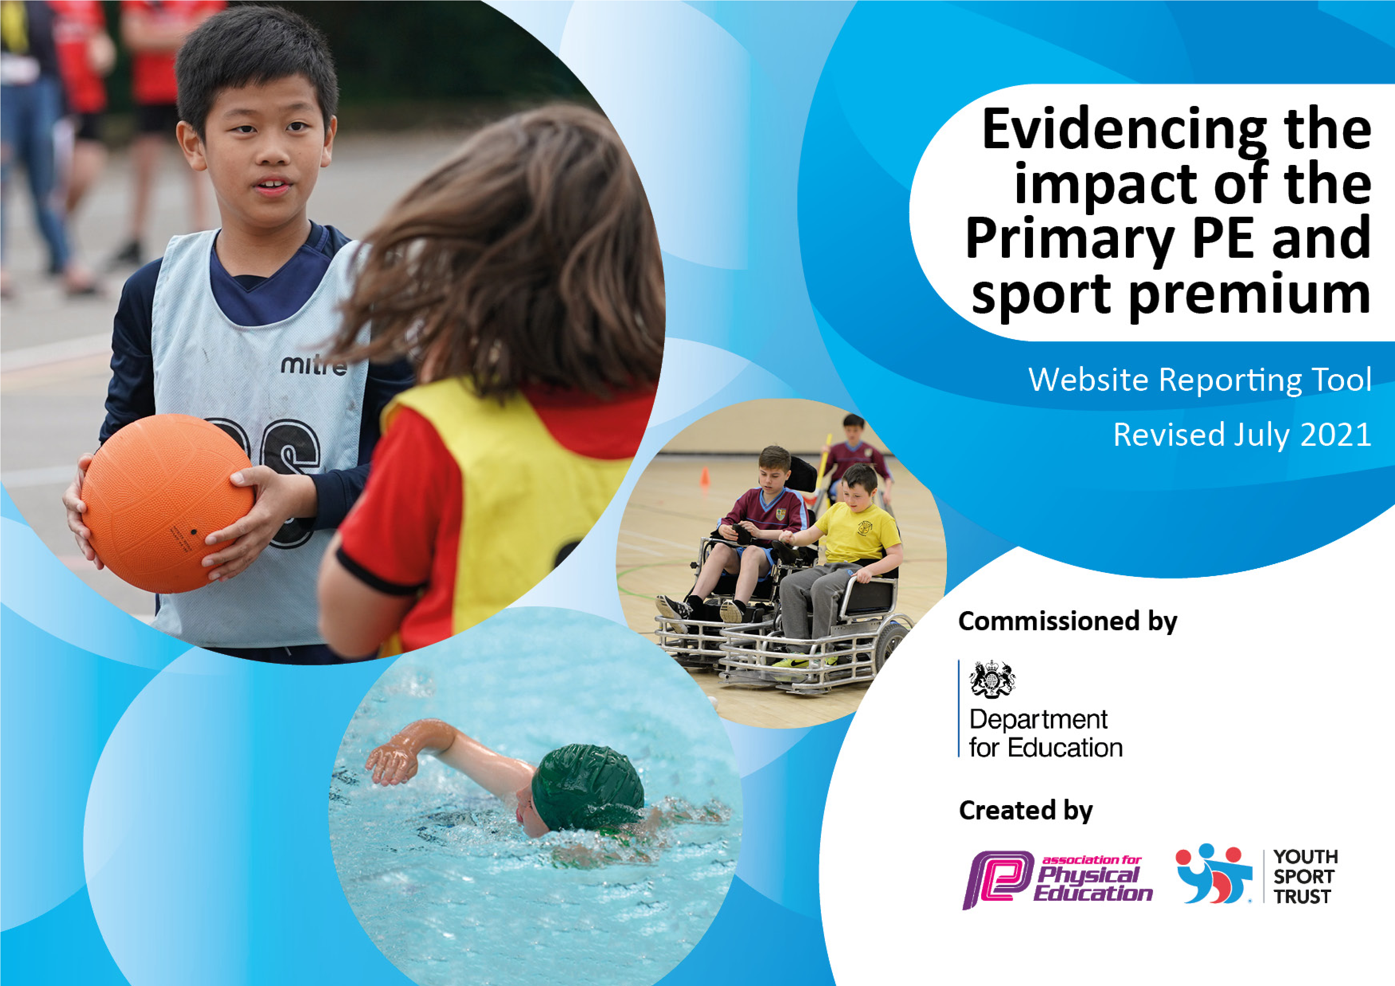

It is important that your grant is used effectively and based on school need. The Education Inspection Framework makes clear there will be a focus on ‘whether leaders and those responsible for governors all understand their respective roles and perform these in a way that enhances the effectiveness of the school’.
Under the Quality of Education Ofsted inspectors consider:
Intent - Curriculum design, coverage and appropriateness
Implementation - Curriculum delivery, Teaching (pedagogy) and Assessment Impact - Attainment and progress
To assist schools with common transferable language this template has been developed to utilise the same three headings which should make your plans easily transferable between working documents.
Schools must use the funding to make additional and sustainable improvements to the quality of Physical Education, School Sport and Physical Activity (PESSPA) they offer. This means that you should use the Primary PE and sport premium to:
- Develop or add to the PESSPA activities that your school already offer
- Build capacity and capability within the school to ensure that improvements made now will benefit pupils joining the school in future years
- The Primary PE and sport premium should not be used to fund capital spend projects; the school’s budget should fund these.
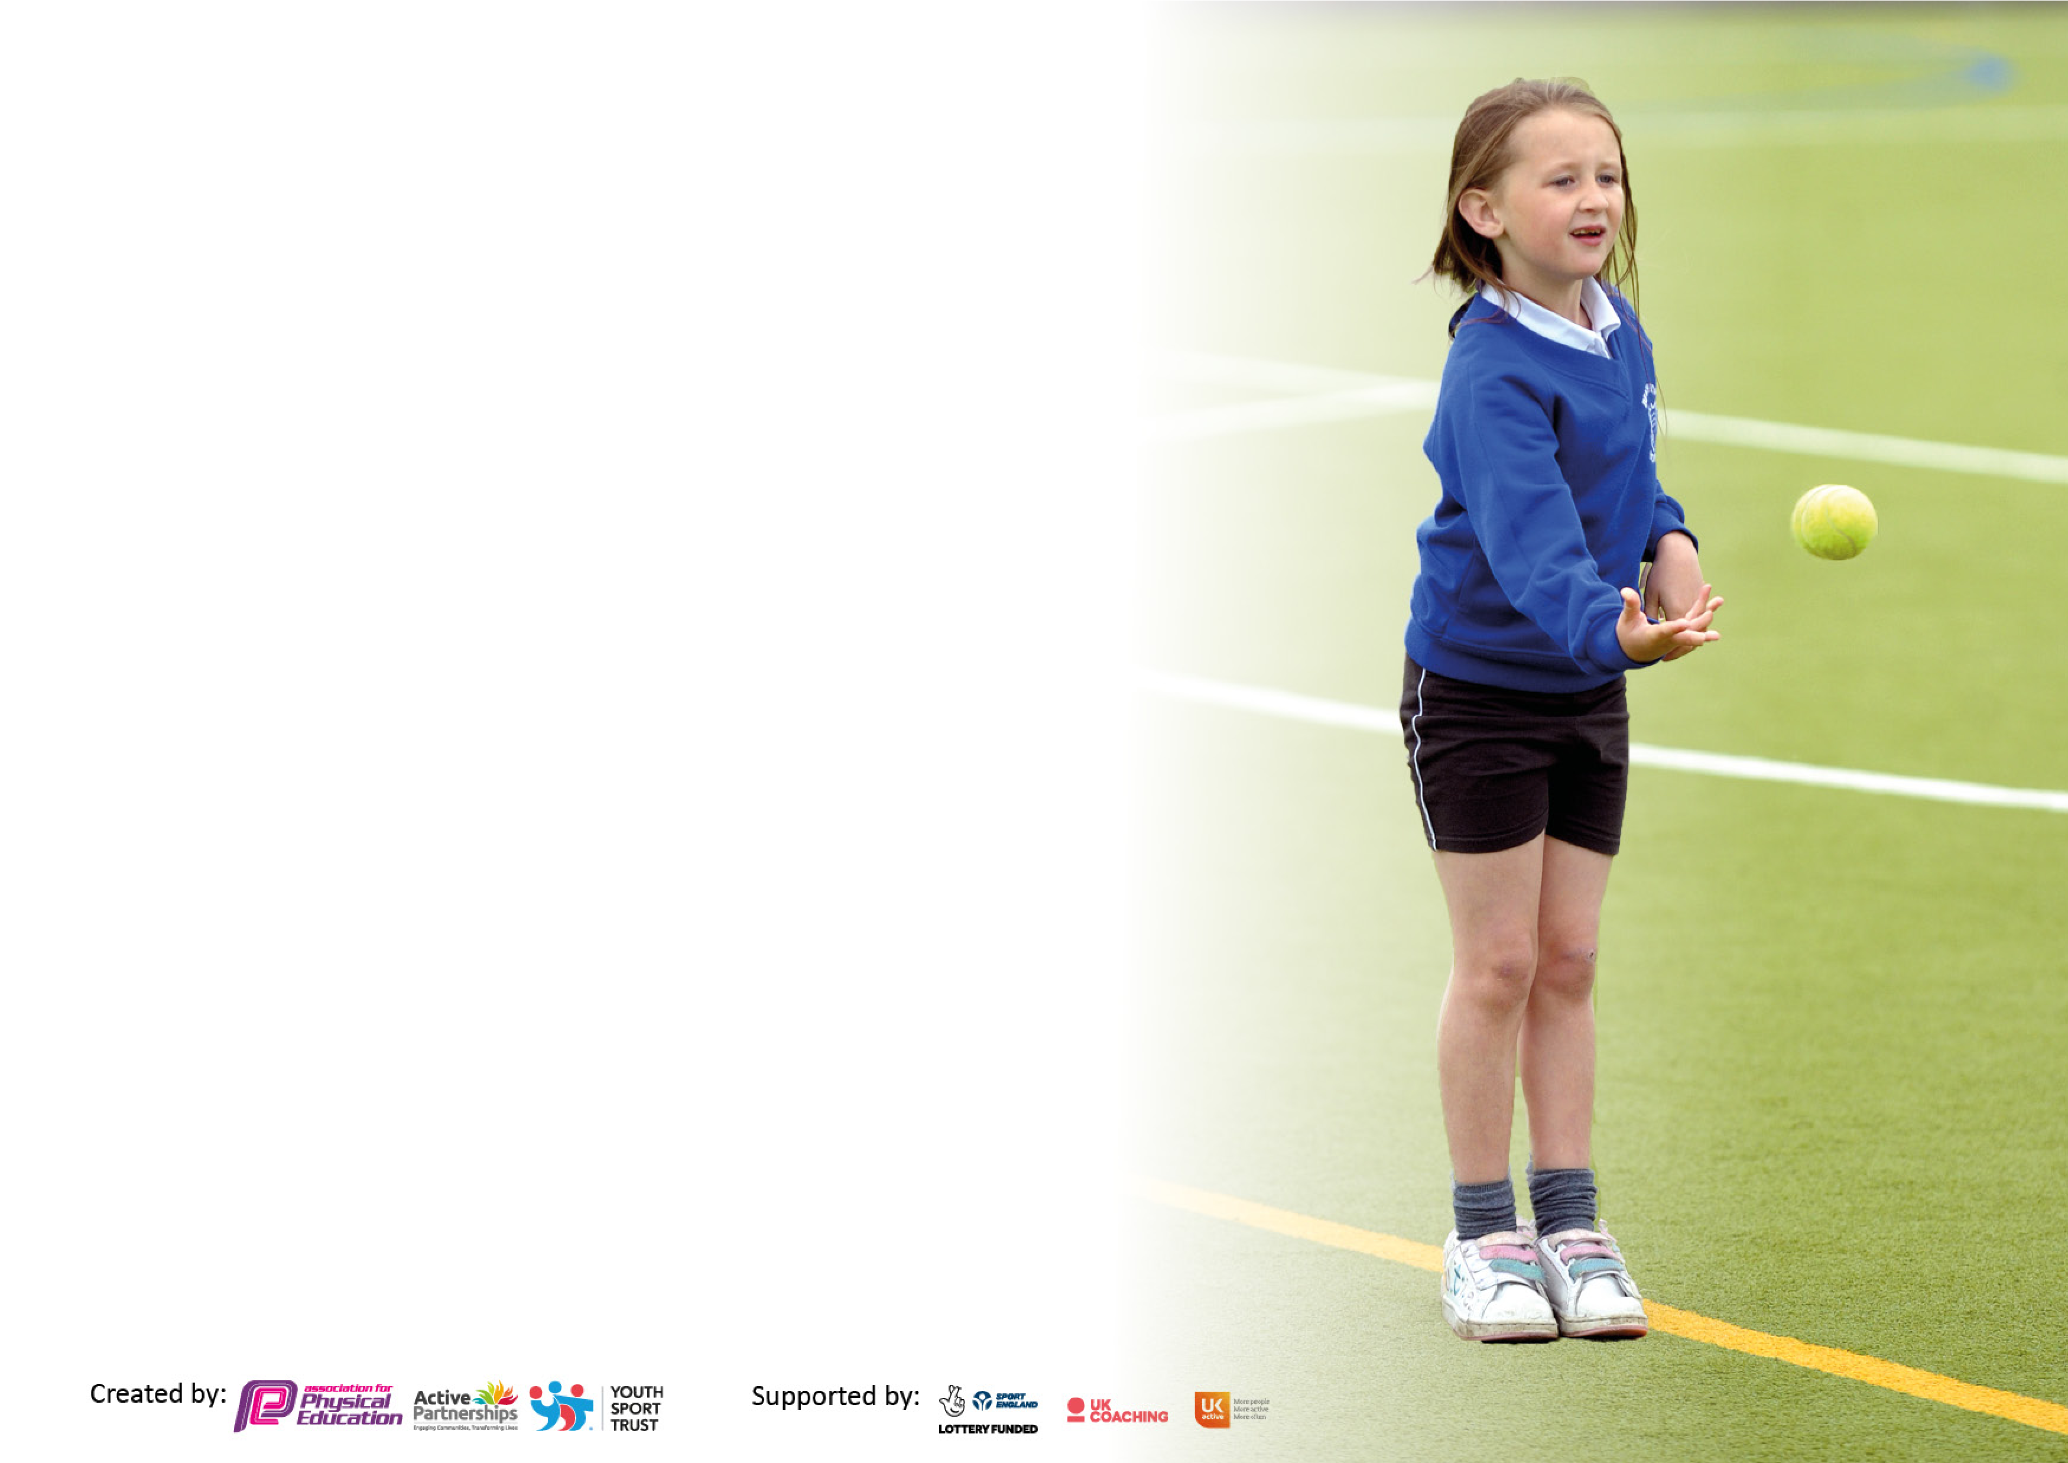
Pleasevisitgov.ukfortherevisedDfEguidanceincludingthe5keyindicatorsacrosswhichschoolsshoulddemonstrate animprovement.Thisdocumentwillhelpyoutoreviewyourprovisionandtoreportyourspend.DfEencouragesschools to use this template as an effective way of meeting the reporting requirements of the Primary PE and sport premium. We recommend you start by reflecting on the impact of current provision and reviewing the previous spend.
Schools are required to publish details of how they spend this funding, including any under-spend from 2022/2023, as well as on the impact it has on pupils’ PE and sport participation and attainment. All funding must be spent by 31st July 2023.
We recommend regularly updating the table and publishing it on your website throughout the year. This

Action Plan and Budget Tracking
Capture your intended annual spend against the 5 key indicators. Clarify the success criteria and evidence of impact that you intend to measure to evaluate for pupils today and for the future.

Academic Year: 2022/23 | Total fund allocated: 16,840 | Date Last Updated: July 2023
Key indicator 1: The engagement of all pupils in regular physical activity – Chief Medical Officers guidelines recommend that primary school pupils undertake at least 30 minutes of physical activity a day in school
Intent | Implementation |  | Impact | Sustainability
Your school focus should be clear what you want the pupils to know and be able to do and about what they need to learn and to consolidate through practice: | Make sure your actions to achieve are linked to your intentions: | Funding allocated: | Evidence of impact: what do pupils now know and what can they now do? What has changed?: | Sustainability and suggested next steps:
- Develop a number of opportunities for pupils to undertake daily physical activity throughout the school day and at home.  - Ensure physical activity is encouraged at playtime. | - Speak to lunchtime supervisors and ensure equipment is out for the children to access/encourage staff to support the children to play games when outside/use Go Noodles when there is a wet playtime  - Use the ASTRO TURF in KS1 and the new Astro Turf in EYFS daily to ensure all children get the chance to use the ball court with equipment at play time | £3200  £150  £3840.00 | - Improved fitness and concentration levels amongst all pupils  - Increasing number of pupils being active at play times which results in improved behaviour across the school and readiness to learn when back in class. | - To continue to ensure that lunchtime staff are confident to support activities and build on their knowledge and confidence at lunch times- both inside for wet playtimes and outside

Key indicator 2: The profile of PESSPA being raised across the school as a tool for whole school improvement
Intent | Implementation |  | Impact
Your school focus should be clear what you want the pupils to know and be able to do and about what they need to learn and to consolidate through practice: | Make sure your actions to achieve are linked to your intentions: | Funding allocated: | Evidence of impact: what do pupils now know and what can they now do? What has changed?: | Sustainability and suggested next steps:
- To continue to ensure that all children are achieving age related expectations within PE. Provide opportunity to all children to achieve in as many  different skills as they can  - Display board in the hall regularly updated with  achievements and rewards in PE  - Play leaders to be trained to teach games and using the equipment appropriately. | - Staff to use the Real PE, Real Gym and Real Dance programmes across Reception and KS1 and to use assessment  tools to observe progress  - Displays to be maintained and changed regularly  - Equipment to be utilised and training for play leaders and children as sports leaders. | £834 | - Children taught and supported with enthusiasm from staff with a passion for PE  - Enhanced quality of teaching and learning  - Improved behaviour and eagerness from pupils to do PE  - Consistency throughout school | - To continue to assess children on their skills within PE and aim to attain  good progress
Key indicator 3: Increased confidence, knowledge and skills of all staff in teaching PE and sport

Intent | Implementation |  | Impact
Your school focus should be clear | Make sure your actions to | Funding | Evidence of impact: what do | Sustainability and suggested
what you want the pupils to know | achieve are linked to your | allocated: | pupils now know and what | next steps:
and be able to do and about | intentions: |  | can they now do? What has
what they need to learn and to consolidate through practice: |  |  | changed?:
- Improving progress and attainment by up-skilling current staff through CPD and Project Sports Coach – Professional Sports coach booked in once a week for the whole year to run Lunchtime sports, After school sports club and PE lessons one afternoon every week. | - Teachers and all support staff to observe all lessons  - develop confidence alongside the Sports Coach A variety of skills being taught as well as the class teacher working alongside coaches in areas they may be less confident in  - PE leader to provide updates in staff meetings after  attending network meetings  - Teachers and other staff members to observe good lessons of other practitioners/  sports coaches/ PE leader  - To use the new Real Dance programme  - Equipment indoors and outdoors to be checked annually for safety standards | £7500.00  £130 | - Staff are now more confident when teaching Real Dance  -  - Staff are more confident due to the ‘Deep Dive’ from  Beyond the Physical  - Subject leader more knowledgeable about the  skills and areas for development in PE.  - Better subject knowledge for  all staff  - Staff continue to be aware of the importance of physical activity | - To have frequent CPD to  upskill staff  - For staff to continue to be able to observe good lessons of other practitioners, sports coaches, PE lead, etc.
Key indicator 4: Broader experience of a range of sports and activities offered to all pupils

Intent | Implementation |  | Impact
Your school focus should be clear | Make sure your actions to | Funding | Evidence of impact: what do | Sustainability and suggested
what you want the pupils to know | achieve are linked to your | allocated: | pupils now know and what | next steps:
and be able to do and about | intentions: |  | can they now do? What has
what they need to learn and to consolidate through practice: |  |  | changed?:
- To buy into Scootfit, Sports for champions Athlete and Yorkshire Sports Foundation for the children and staff to be able to partake in a wide variety of activities.  - Staff to run Sports day to give more children a chance to partake in a variety of physical activities | - Opportunities for all of the children to try a variety of activities and equipment that  may be new to them, e.g.  balance bikes, multi-skills, mini gym equipment, dance mats, team building, Boccia. | £ 1000.00  £200 | - Children have tried something new that they may not have experienced at home, resulting in children asking to use different equipment and eager to complete physical activities - Children are more confident in using a range of equipment - Teachers confidence has improved by observing different coaches and different activities. - Children’s experiences of different sports.  - Children have learnt new active to play and are eager to partake in physical activity | - To continue to hire different coaches to develop the skills of the children and to continue to have different physical after school clubs to develop further skills
Key indicator 5: Increased participation in competitive sport
Intent | Implementation |  | Impact
Your school focus should be clear | Make sure your actions to | Funding | Evidence of impact: what do | Sustainability and suggested
what you want the pupils to know | achieve are linked to your | allocated: | pupils now know and what | next steps:
and be able to do and about | intentions: |  | can they now do? What has
what they need to learn and to consolidate through practice: |  |  | changed?:
- For children to partake in intra competitions between schools to develop the importance of team work, communication, ambition, attitude and academic achievement | - Multi-skills events to be arranged with local schools from Reception to Year 2 and SEND. | £250 | Children will have the opportunity to compete and take part in sporting activities with children from other schools. Headfield & Savile Town school to help with supervision with young sports leaders

Signed off by
Head Teacher: | Pat Barker
Date: | 20.12.22
Subject Leader: | Pat Barker
Date: | 20.12.2022
Governor: | Gail Gerrard
Date: | 22.12.2022

