Pentland Infant and Nursery School Newsletter
July 2023
Dear Parents/Carers,
As the academic year draws to a close, I would like to take this opportunity to say a huge ‘Thank you’ to our parents, children, staff and governors for a fantastic year. We have celebrated many successes this year and have shared so many joyful experiences, not to mention the fond memories we have made together as a school community!
Thank you so much for all the support you have shown us by attending special assemblies and events throughout the year. The Year 2 Leavers Assembly was spectacular and a particular highlight this week and although it is a bittersweet time for us saying goodbye to our Year 2 children, we are also excited to see them progress to the next stage in their lives. We look forward to following the successes of our children as they grow up and hope to see them again soon in the future.
It was lovely to see so many of you at our 100% attendance assembly this week too. We are extremely proud of our children and parents who bring their children to school every day. We even had a child who won the ‘best attendance all year’ award and won a £10 voucher. We look forward to seeing even more children receive 100% attendance awards next academic year.
Please look after yourselves and each other and have an amazing Summer break. The staff and I wish you all the best and hope you have lots of fun and get a bit of rest too!
Miss Fauzia Farooq
Summer Fair
Thank you for making our Summer Fair a massive success! We have had such brilliant feedback from children, parents and the community! 🌟
Those of you who managed to attend the fair will have seen the array of fantastic stalls from cakes, food, toys, jewellery, clothes to the barbeque, bouncy castles and child friendly go carts!
There was a real community feel to the day and it was an enjoyable day for all!
With your help, school managed to raise £1,156.00 which will go towards resources for our children, playground equipment and experiential learning opportunities…a massive heartfelt thank you to each and every one of you! 🌟😊
Reminders
If you would like your child to have milk in school from September, please ensure you pay via ParentPay by Friday 21st July 2023.
Please apply for free school meals/milk using this link: https://www.kirklees.gov.uk/beta/schools/free-school-meals.asp
As of the 6th September 2023 please remember that our new school day starts at 8.50am and finishes at 3.20pm. Thank you.

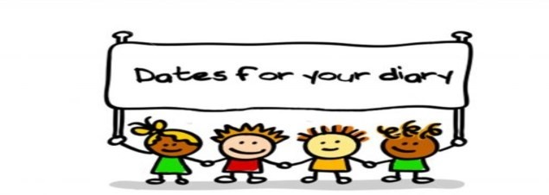
Dates for the diary:

Wednesday 6th September 8.50am School starts for Year 1 and Year 2 children. Staggered transition for EYFS children (please refer to your individual letter for start dates and times.
The last day of Summer Holidays is Tuesday 5th September 2023.

October half term holiday Monday 30th October to Friday 3rd November 2023 (Last day of term Friday 27th October 2023 and first day back Monday 6th November 2023).

Christmas holiday Monday 25th December to Friday 5th January 2024 (Last day of term Friday 22nd December 2023 and first day back Monday 8th January 2024).

February half term holiday Monday 12th February to Friday 16th February 2024 (Last day of term Friday 9th February 2024 and first day back Monday 19th February 2024).

Easter holiday Monday 25th March to Friday 5th April 2024 (Last day of term Friday 22nd March 2024 and first day back Monday 8th April 2024).
May Bank Holiday Monday 6th May.
May half term holiday Monday 27th May to Friday 31st May 2024 (Last day of term Friday 24th May 2024 and first day back Monday 3rd June 2024).
Summer holiday Last day of term Friday 19th July 2024.
INSET Training Days
Monday 4th September 2023
Tuesday 5th September 2023
Friday 24th November 2023
Monday 17th June 2024
Monday 22nd July 2024
Goodbye and all the best…

Sadly, we are saying farewell to a number of staff who are moving on to pastures new as follows; Safiya Mulla, Ibrat Wahid, Fatima Mulla, Irfana Patel, Fozila Akhtar, Sadiyah Mulla, Uzma Arif and Rukhaya Kara.

We wish them the best of success in all of their future endeavours. 🌟 They will be greatly missed by all the children, staff, parents and governors and collectively they have been at the very heart of our school community for many, many years.

Farewell our dear friends, please come back and visit us! 😊

