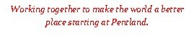

MODEL SAFEGUARDING & CHILD
PROTECTION POLICY FOR SCHOOLS & COLLEGES

Academic Year 2022-23

Kirklees Council Model Safeguarding and Child Protection Policy 2022-23 1

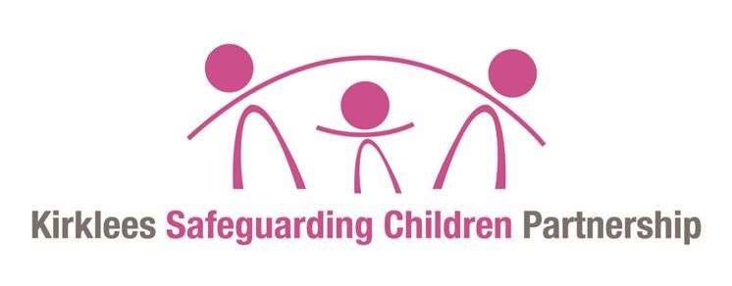

OVERVIEW ............................................................................................................................................... 3 1. AIMS ............................................................................................................................................. 4
2. LEGISLATION AND STATUTORY GUIDANCE .............................................................................................. 4 3. DEFINITIONS .................................................................................................................................... 6
4. EQUALITY STATEMENT ....................................................................................................................... 6 5. ROLES AND RESPONSIBILITIES ............................................................................................................. 6 6. CONFIDENTIALITY ........................................................................................................................... 11 7. OUR ROLE IN THE PREVENTION OF ABUSE ............................................................................................ 13 8. OUR ROLE IN SUPPORTING CHILDREN .................................................................................................. 15 9. RESPONDING TO DOMESTIC ABUSE .................................................................................................... 24 10. EDUCATION SAFEGUARDING ......................................................................................................... 25 11. A SAFER SCHOOL CULTURE .......................................................................................................... 27
12. MANAGING ALLEGATIONS ................................................................................................................... 32 When we will refer to the LADO:.................................................................................................... 32
Reasons for an allegation .............................................................................................................. 32 13. CHILD PROTECTION RECORDS ....................................................................................................... 33
APPENDIX 1 ........................................................................................................................................... 37
DEFINITIONS AND INDICATORS OF ABUSE ...................................................................................................... 37
APPENDIX 2 ........................................................................................................................................... 42
DEALING WITH A DISCLOSURE OF ABUSE ....................................................................................................... 42 APPENDIX 6 ........................................................................................................................................... 43
CHILD EXPLOITATION PARTNERSHIP ASSESSMENT AND DECISION-MAKING TOOL ................................................. 43
APPENDIX 7 ........................................................................................................................................... 52
KSCP HARMFUL SEXUAL BEHAVIOUR RESPONSE CHECKLIST ............................................................................ 52
APPENDIX 8 ........................................................................................................................................... 55
RADICALISATION RESPONSE CHECKLIST ........................................................................................................ 56
APPENDIX 9 ........................................................................................................................................... 57
MISSING FROM SCHOOL RESPONSE CHECKLIST.............................................................................................. 57

APPENDIX 11 ......................................................................................................................................... 59 EARLY SUPPORT MULTI AGENCY PANEL PROCESS .......................................................................................... 59

Kirklees Council Model Safeguarding and Child Protection Policy 2022-23 2

Overview

This Safeguarding & Child Protection Policy is available on the Kirklees Business Solutions School Safeguarding Officers page website and is reviewed and ratified annually.
Part 1 of this policy is for all staff and governors.
Part 2 is principally for use by Designated Safeguarding Staff, lead governors, and senior leadership teams.
Part 2 of this policy document has a suite of model Pro-forma for schools to adapt to support their inhouse safeguarding arrangements.
Academic year | Designated  Safeguarding Lead | Deputy Designated  Safeguarding Lead/s | Nominated  Governor | Chair of  Governors
2022-23 | Fauzia Farooq | Dawn Rushby | Elnaz Yazdani | Ashraf Mulla

Policy Review date | Date Ratified by governors | Date Shared with staff
September 22 | 12.10.22 | 6.9.22

Aims
The school aims to ensure that:
- Appropriate action is taken promptly to safeguard and promote children’s welfare.
- All staff are aware of their statutory safeguarding responsibilities.
- Staff are properly trained in recognising and reporting safeguarding issues.
- The Governing Body and staff of Pentland Infant & Nursery School take as our priority the responsibility to safeguard and promote the welfare of our pupils, to minimise risk, and to work together with other agencies to ensure rigorous arrangements are in place within our school to identify, assess and support those children who are suffering harm and to keep them safe and secure whilst in our care.
- The responsibilities set out in this policy apply (as appropriate) to all members of the school community including pupils, staff, governors, visitors/contractors, volunteers, and trainees working within the school. It is fully incorporated into the whole school ethos and is underpinned throughout the teaching of the curriculum, within Personal, Social and Health Education (PSHE) and the safety of the physical environment provided for the pupils.

Legislation and statutory guidance
- This policy is based on the Department for Education’s statutory guidance, Keeping Children Safe in Education 2022, Working Together to Safeguard Children (WTTSC 2018) and sexual violence and sexual harassment between children in schools and colleges we comply with this guidance and the procedures set out by Kirklees Safeguarding Children partnership (KSCP)
- The policy conforms to locally agreed inter-agency procedures and has been developed by Kirklees Education Safeguarding Service and Kirklees Safeguarding Children’s Partners. It is available to all interested parties on our website and by request from the main school office. It should be read in conjunction with other relevant policies and procedures and Keeping Children Safe in Education.
This policy is also based on the following legislation:
- Section 175 of the Education Act 2002, places a duty on schools and local authorities to safeguard and promote the welfare of pupils.
- The School Staffing (England) Regulations 2009, sets out what must be recorded on the single central record and the requirement for at least one person on a school interview/appointment panel to be trained in safer recruitment techniques.

- The Children Act 1989 (and 2004 amendment), provides a framework for the care and protection of children.
- General Data Protection Act (2019) Guide to the General Data Protection Regulation - GOV.UKhttps://www.gov.uk/government/publications/guide-to-the-general-data-protectionregulation.
- Data Protection Act http://www.legislation.gov.uk/ukpga/2018/12/contents/enactedSection
5B(11) of the Female Genital Mutilation Act 2003, as inserted by section 74 of the Serious Crime Act 2015, which places a statutory duty on teachers to report to the police where they discover that female genital mutilation (FGM) appears to have been carried out on a girl under 18.
- Statutory guidance on FGM sets out responsibilities for safeguarding and supporting girls affected by FGM.
- The Rehabilitation of Offenders Act 1974, outlines when people with criminal convictions can work with children.
- Schedule 4 of the Safeguarding Vulnerable Groups Act 2006, defines what ‘regulated activity’ is about children.
- Statutory Guidance on the Prevent duty, which explains schools’ duties under the CounterTerrorism and Security Act 2015 for protecting people from the risk of radicalisation and extremism.
- Children and Social Work Act 2017 https://www.legislation.gov.uk/ukpga/2017/16/contents/enacted
- Guidance for safer working practices for those working with children and young people in education settings https://www.saferrecruitmentconsortium.org/.
- Kirklees Safeguarding Children Partnership Procedures https://www.kirkleessafeguardingchildren.co.uk/procedures-local-protocols-and-guidance/.
- Children Missing Education – Statutory guidance for local authorities (DfE September 2016) https://www.gov.uk/government/publications/children-missing-education.
- The Childcare (Disqualification) Regulations 2018 and Childcare Act 2006, set out who is disqualified from working with children.
- This policy also meets requirements relating to safeguarding and welfare in the statutory framework for the Early Years Foundation Stage.
- https://assets.publishing.service.gov.uk/government/uploads/system/uploads/attachment_data /file/999239/SVSH_2021.pdf.

Definitions
Safeguarding and promoting the welfare of children means:
- Protecting children from maltreatment.
- Preventing impairment of children’s mental and physical health or development.
- Ensuring that children grow up in circumstances consistent with the provision of safe and effective care.
- Taking action to enable all children to have the best outcomes.
- Child protection is part of this definition and refers to activities undertaken to prevent children from suffering or being likely to suffer, significant harm.
- Children include everyone under the age of 18.

Equality Statement
Some pupils have an increased risk of abuse, and additional barriers can exist for some pupils for recognising or disclosing it. We are committed to anti-discriminatory practice and recognise pupils’ diverse circumstances. We ensure that all pupils have the same protection, regardless of any barriers they may face.
We give special consideration to pupils who:
- Have special educational needs or disabilities.
- Are young carers.
- May experience discrimination due to their race, ethnicity, religion, gender identification or sexuality.
- Have English as an additional language.
- Are known to be living in difficult situations – for example, temporary accommodation or where there are issues such as substance abuse or domestic violence.
- Are at risk of Female Genital Mutilation (FGM), sexual exploitation, criminal exploitation, forced marriage, or radicalisation.
- Are asylum seekers, refugees or migrants.

Roles and responsibilities
Safeguarding and child protection is everyone’s responsibility. This policy applies to all staff (including those not directly employed by this school), volunteers, and governors in this school. Our policy and procedures also apply to extended school and off-site activities.
All staff
- All staff will read and understand part 1 and Annex B of the Department for Education’s statutory safeguarding guidance, Keeping Children Safe in Education (KCSiE) and review this guidance at least annually.
All staff will be aware of:
- Our systems to support safeguarding, include Guidance for Safer Working Practice, the role of the designated safeguarding lead (DSL), the behaviour policy, and the safeguarding response to pupils who go missing from education.
- The early support process includes identifying emerging problems, liaising with the DSL, and sharing information with other professionals to support early identification and assessment.
- The process for making referrals to Kirklees children’s services duty and advice and for statutory assessments that may follow a referral, including the role they might be expected to play. (Fig 1 page 10) illustrates the procedure to follow if you have concerns about a child’s welfare. Wherever possible, speak to the DSL, deputy DSL, or head teacher (in the absence of a DSL) first to agree on a course of action. In the absence of a DSL or head teacher being available, staff must not delay directly contacting the duty and advice team or the police if they believe a child is at immediate risk of significant harm.
- Working in partnership with other agencies in the best interests of the children. Requests for service to children’s social care duty and advice team should (wherever possible) be made by the designated safeguarding lead. Where a pupil already has a child protection social worker, we will immediately contact the social worker involved or in their absence, the team manager of the child protection social worker.
- The signs of different types of abuse and neglect, as well as specific safeguarding issues, such as child sexual exploitation (CSE), child criminal exploitation (CCE), female genital mutilation (FGM) and radicalisation.
- What to do if they identify a safeguarding issue or a pupil tells them they are being abused or neglected, including specific issues such as child exploitation or female genital mutilation (FGM), and how to maintain an appropriate level of confidentiality while liaising with relevant professionals.
- In-school procedures for recording any cause for concerns and passing information on to DSLs following the school’s recording systems.

Appendix 1 definitions of abuse.
Appendix 2 guidance to staff on how to handle disclosures.
The designated safeguarding lead (DSL) and deputy designated staff:
- Our DSL is Pat Barker- Interim Headteacher The DSL takes the lead responsibility for child protection and wider safeguarding.
- During term time, the DSL will be available during school hours for staff to discuss any safeguarding concerns.
Pat Barker- pat.barker@pentlandinf.co.uk-07729664708
- When the DSL is absent, the [deputy/deputies] – Dawn Rushby SENco of deputy– will act as cover.

If the DSL and deputy are not available any available teacher will act as cover (for example, during out-of-hours/out-of-term activities).
The DSL will be given the time, training, resources and support to:
- Respond to daily Operation Encompass notices when required.
- Provide advice and support to other staff on child welfare and child protection matters.
- Take part in strategy discussions and inter-agency meetings and/or support other staff to do so.
- Contribute to the assessment of pupils.
- Refer suspected cases, as appropriate, to the relevant body (children’s social care duty and advice team, Channel programme, and/or police), and support staff to comply with their mandatory reporting duties in cases where Female Genital Mutilation has been identified.
- Pat Barker- interim Head will ensure that all staff involved in direct case work of vulnerable pupils, where there are child protection concerns/issues, have access to regular safeguarding supervision.
- The DSL will also keep the Head teacher informed of any issues and liaise with local authority officers and relevant professionals for child protection concerns as appropriate.
- We will ensure representation at appropriate inter-agency meetings such as Initial and Review Child Protection Conferences, Planning and Core Group meetings, as well as team around the family meetings (TAF).
- Provide reports as required for meetings. If we are unable to attend a meeting, a written report will be sent. Reports will, wherever possible, be shared with parents/carers at least 24 hours before the meeting.
- Where a pupil in school is subject to an inter-agency child protection plan or any multi-agency risk management plan, the designated safeguarding lead will contribute to the preparation, implementation and review of the plan as appropriate.
The full responsibilities of the DSL are set out in Annex C of Keeping Children Safe in Education (KCSiE) – Role of the designated safeguarding lead. All designated safeguarding leads and deputy safeguarding leads must read and comply with this.
(https://www.gov.uk/government/publications/keeping-children-safe-in-education--2)

The Governing Body

- The Governing body will complete appropriate safeguarding and child protection (including online) training at induction.
- The governing body will approve this policy at each review and hold the head teacher to account for its implementation.
- The governing body will appoint a lead governor to monitor the effectiveness of this policy in conjunction with the full governing body. The DSL cannot also be the lead governor with responsibility for child protection.
- If an allegation of abuse is made against the head teacher, the chair of governors will act as the ‘case manager’.
The governing body, along with the school’s senior leadership team, is responsible for satisfying themselves and obtaining written assurances from any relevant school lettings and alternative/off-site providers and provisions that their safeguarding arrangements are secure and in keeping with Keeping Children Safe in Education (KCSiE). This school use the following alternative or off-site providers and has written evidence of safeguarding arrangements.
The full responsibilities of the governing body are set out in Part Two of KCSiE – The management of safeguarding. All governing bodies should read Part Two of KCSiE to ensure that the school is fully compliant with its statutory safeguarding responsibilities.
The Head Teacher
The head teacher is responsible for the implementation of this policy, including:
- Ensuring that staff (including temporary staff) and volunteers are informed of this policy as part of their induction.
- Communicating this policy to parents when their child joins the school and via the school website.
- Ensuring that the designated safeguarding lead has appropriate time, training and resources and that there is always adequate cover if the DSL is absent.
- Ensuring that all staff undertake appropriate safeguarding and child protection training and update this regularly.
- Acting as the ‘case manager’ in the event of an allegation of abuse made against another member of staff or volunteer, where appropriate.
- Ensuring the relevant staffing ratios are met, where applicable.
- Make sure each child in the Early Years Foundation Stage is assigned a key person.
Fig 1 Summary of School Procedure to Follow Where There Are Concerns about a Child

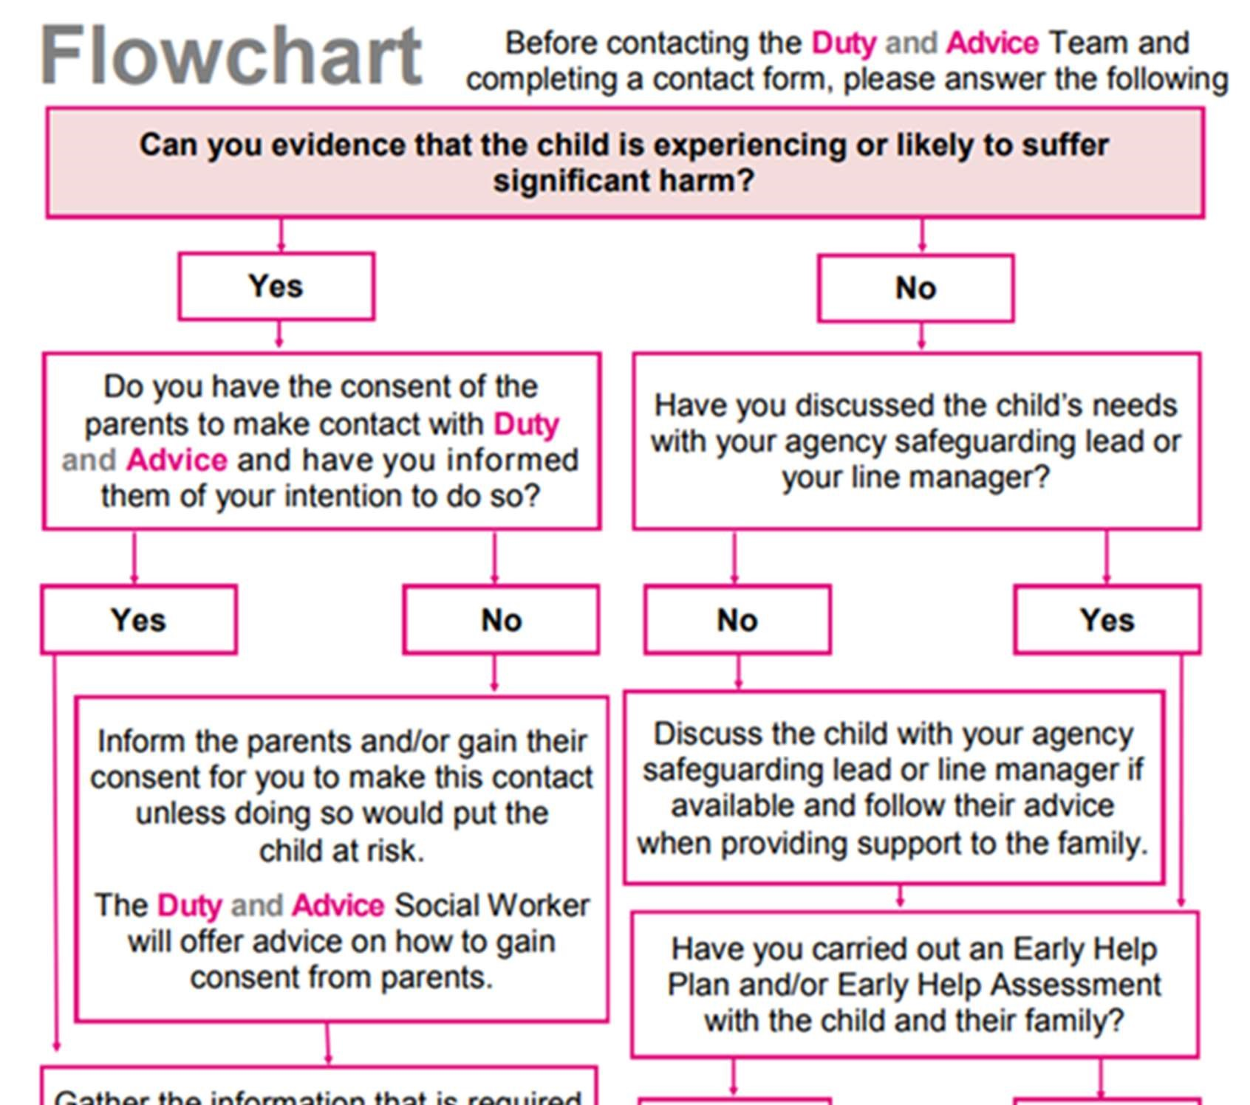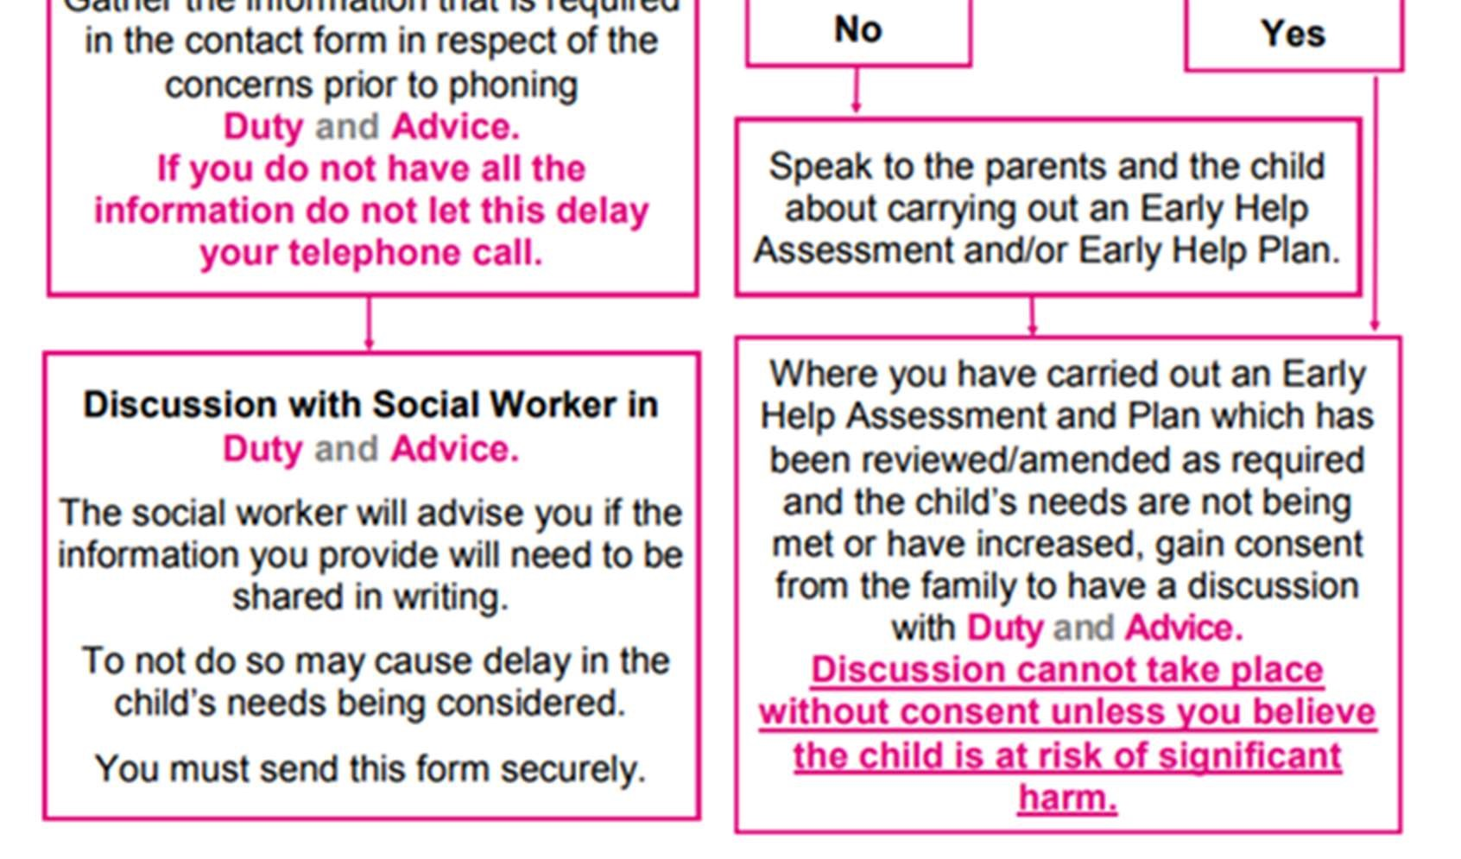

Confidentiality

- Confidentiality is an issue that needs to be understood by all those working with pupils, particularly in the context of safeguarding.
- This School recognises that the only purpose of confidentiality in this respect is to benefit the pupil. Staff, volunteers, and visitors to the school should never promise a pupil that they will not tell anyone about an allegation or disclosure and must pass any cause for concern immediately to a designated safeguarding lead.
- Confidentiality is addressed throughout this policy for record-keeping (section 13), dealing with disclosure (Appendix 2), allegations of abuse against staff (section 12), information sharing and working with parents (section 6).
Record Keeping, Information sharing and GDPR
- Timely information sharing is essential for effective safeguarding. This School will share safeguarding information as appropriate in keeping with the principles outlined in the government guidance document, Information sharing: Advice for practitioners providing safeguarding services to children, young people, parents and carers (DfE 2018). This guidance has been produced to support practitioners in the decisions they take to share information, which reduces the risk of harm to children and young people and promotes their well-being.
- All concerns, discussions and decisions made, and the reasons for those decisions will be recorded in writing or electronically. Information will be kept confidential and stored securely.
Records will include;
  - A clear comprehensive summary of the concern.
  - Details of how the concern was followed up and resolved.
  - A note of any action taken, decisions reached and the outcome.
- The storing and processing of personal data are governed by the General Data Protection Regulations 2017 (GDPR) and Data Protection Act 2018. This school will give clear advice to staff about their responsibilities under this legislation so that, when considering sharing confidential information, those principles should apply.
- Staff may have access to special category personal data about pupils and their families which must be always kept confidential and only shared when legally permissible to do so and in the interest of the child. Records should only be shared with those who have a legitimate professional need to see them.

Working with parents and other agencies to protect children
- Parents/carers should be aware that our school will take any reasonable action to safeguard the welfare of its pupils. In cases where the school has reason to be concerned that a child may be suffering significant harm, ill-treatment or neglect, or other forms of harm, staff have no alternative but to follow the Kirklees Safeguarding Children’s Partnership procedures and contact the duty and advice team to discuss their concerns.
- In keeping with Keeping Children Safe in Education (KCSiE) and Children missing education: statutory guidance for local authorities. we will endeavour wherever possible to obtain at least two emergency contacts for every child in the school in case of emergencies, and in case there are welfare concerns at the home.
- In general, we will discuss concerns with parents/carers before approaching other agencies and will seek to inform parents/carers and receive their consent when making a referral to another agency. Appropriate staff will approach parents/carers after consultation with the designated safeguarding lead. The exception to this rule will be in situations where a member of staff has reasonable cause to believe that informing parents/carers of a referral to another agency may increase the risk of significant harm to the pupil.
- Parents/carers are informed about our safeguarding policy through the school prospectus, website, newsletters etc. A safeguarding and child protection statement is prominent in the school foyer/reception area.
Multi-agency work
- We will co-operate with childrens social care duty and advice (DAAT) by following the requirements of the Children Act and allowing access to pupil and child protection records for them to conduct section 17 or section 47 assessments.
- In the best interests of our pupils, we will work with all relevant professionals and agencies as required to safeguard children and promote their welfare.

Our role in the prevention of abuse

• We will identify and provide opportunities for children to develop skills, concepts, attitudes and knowledge to promote their safety and well-being.

The curriculum
- This school understands the importance of delivering an effective safeguarding curriculum which includes:
- Healthy and respectful relationships.
- Boundaries and consent.
- Stereotyping, prejudice, and equality.
- Body confidence and self-esteem, wellbeing and resilience.
- Relevant issues will be addressed through Relationships Education (for all primary schools) and Relationships and Sex Education for all secondary pupils and health education (for all pupils in state-funded schools) is mandatory from September 2020. All children should be safeguarded from potentially harmful and inappropriate online material (online bullying, sexting, child sexual exploitation (CSE), child criminal exploitation (CCE), gangs, youth-generated images, female genital mutilation (FGM), preventing radicalisation, peer on peer abuse and anti- bullying.
- Relevant issues will be addressed through other areas of the curriculum. For example, circle time, English, History, Drama, PSHE, Art and assemblies.
Online Safety
- This School is committed to meeting the requirement to keep pupils safe when using technology. We believe the whole school community can benefit from the opportunities provided by the internet and other technologies used in everyday life. The breadth of issues classified within online safety is considerable, but can be categorised into four areas of risk:

- Content: being exposed to illegal, inappropriate, or harmful content; for example, pornography, fake news, racism, misogyny, self-harm, suicide, anti-semitism, radicalisation and extremism.

- Contact: being subjected to harmful online interaction with other users; for example, child to child pressure, commercial advertising and adults posing as children or young adults to groom or exploit them for sexual, criminal, financial, or other purposes.

- Conduct: personal online behaviour that increases the likelihood of, or causes, harm; for example, making, sending, and receiving explicit images (e.g. consensual and non-consensual sharing of nudes and semi-nudes and/or pornography, sharing other explicit images) and online bullying; and

- Commerce: risks such as online gambling, inappropriate advertising, phishing, and/or financial scams.

- Our schools' expectations for responsible and appropriate conduct are set out in the school online safety policy and acceptable use policies (AUP) which we expect all staff and pupils to follow.

Other areas of work
- All our policies that address issues of power and potential harm, e.g., Anti- Bullying, Equal Opportunities, Positive Handling, and Behaviour, will be linked to ensure a whole school approach.
- Our Safeguarding and Child Protection policy cannot be separated from the general ethos of the school which ensures that children are treated with respect and dignity, feel safe, and are listened to.
- Safeguarding incidents and/or behaviours can be associated with factors outside the school or college and can occur between pupils outside the school or college. All staff, but especially the designated safeguarding lead and deputy designated safeguarding lead will consider the context within which such incidents and behaviours occur. This is known as Contextual Safeguarding, which simply means assessments of children should consider whether wider environmental factors are present in a child’s life that are a threat to their safety and welfare.

Our role in supporting children
- We will offer appropriate support to individual children who have experienced abuse or who have abused others. In cases where pupils have experienced abuse/abused others, the designated safeguarding lead will ensure that appropriate support is offered. An individual risk assessment will be devised, implemented, and reviewed regularly should the pupil (victim, perpetrator, or other child affected) require additional pastoral support/intervention.
- Our staff are aware that children may not feel ready or know how to tell someone that they are being abused, exploited, or neglected, and/or they may not recognise their experiences as harmful. For example, children may feel embarrassed, humiliated, or threatened. This could be due to their vulnerability, disability, cultural expectations and/or sexual orientation or language barriers. This will not prevent our staff from having a professional curiosity and speaking to the DSL if they have concerns about a child. This school will determine how best to build trusted relationships with children and young people which facilitate communication.
Early Support
- If we identify additional unmet needs for a pupil that does not require intervention by social workers, then in the first instance it may be beneficial to speak to the casework consultant linked to our community hub. They can advise us whether family support may be required, this may help us to understand what support we can offer if we complete an Early Support
Assessment (ESA). The Early Support Assessment is a tool and not a referral mechanism.
- For pupils, whose needs and circumstances make them more vulnerable, a coordinated multidisciplinary approach is usually best, based on an Early Support Assessment, with a Lead
Practitioner to work closely with the child and family to ensure they receive the right support.
Early Support Assessment (ESA) explained
- The school will gather further information, if required, to provide evidence when statutory services are needed.
- If it is not clear who is best placed to provide support, an early support assessment (ESA) will be undertaken before a referral is made to the Early Support Service.
- If additional support is required from the Early Support Service, then a referral will be made by the school. The school will in most cases consider completing an Early Support Assessment to ensure the right level of support is offered. (Appendix 11).
- The Kirklees Safeguarding Children Partnership monitors referrals to Early Support to promote improvement in assessment practice within all partner agencies.
- If the school undertake a referral which relates to a family where there is an existing team around the family meeting (TAF) an early support assessment (ESA) will already have been completed.
Early Support - The Kirklees Early Support Partnership - KSCP (kirkleessafeguardingchildren.co.uk) Children in Specific Circumstances
We recognise that all children can be at risk of abuse however we acknowledge that some groups are more vulnerable, this can include:
- the experience of abuse within their family.
- young people in care.
- children who go missing.
- children with additional needs (SEN and/or disabilities) .
- children living with domestic violence or drug/alcohol abusing parents.
- This school follows the Kirklees Safeguarding Children Partnership
(https://www.kirkleessafeguardingchildren.co.uk/) online multi-agency procedures and will, where necessary, have due regard to the government guidance for children in specific circumstances as outlined in Part 1 and Annex B of Keeping Children Safe in Education (KCSiE).

Female Genital Mutilation (FGM) the Mandatory Reporting Duty
- The Department for Education’s Keeping Children Safe in Education explains that FGM comprises “all procedures involving partial or total removal of the external female genitalia or other injuries to the female genital organs.”
- FGM is illegal in the UK and a form of child abuse with long-lasting, harmful consequences. It is also known as ‘female genital cutting’, ‘circumcision’ or ‘initiation.’
- Any teacher who discovers that an act of FGM appears to have been carried out on a pupil under 18 will immediately (in consultation with the designated safeguarding lead) report this to the police, personally. This is a statutory duty, and teachers will face disciplinary sanctions for failing to meet it.
- The duty above does not apply in cases where a pupil is at risk of FGM or FGM is suspected but is not known to have been carried out. Staff will not examine pupils.
- Any other member of staff who discovers that an act of FGM appears to have been carried out on a pupil under 18 will speak to the designated safeguarding lead and follow our local safeguarding procedures.
Honour-based abuse (including forced marriage)

This School recognise that Honour-based abuse (HBA) encompasses incidents that have been committed to protect or defend the honour of the family and/or the community. Abuse committed in this context often involves a wider network of family or community pressure and can involve multiple perpetrators. If staff in our school have a concern regarding a pupil that might be at risk of HBA or who has suffered from HBA they will immediately speak to the designated safeguarding lead who will follow the school safeguarding procedures.
Further information and resources can be found via the links below:
https://www.kirkleessafeguardingchildren.co.uk/safeguarding-2/different-types-of-abuse/honourbased-violence/

Preventing Radicalisation
- Radicalisation is defined as the process by which people come to support terrorism and violent extremism and, in some cases, then participate in terrorist groups. For further information on this subject please refer to page 147 of Keeping Children Safe in Education (2022).

Responding to concerns about radicalisation
- If staff are concerned about a change in the behaviour of an individual or see something that concerns them (this could be a colleague too) they will seek advice appropriately with the designated safeguarding lead who will contact The Prevent Hub–01924 483747 for further advice (appendix 8).

- We will assess the risk of pupils being drawn into terrorism, including support for extremist ideas that are part of terrorist ideology. This means being able to demonstrate both a general understanding of the risks affecting pupils in the area and a specific understanding of how to identify individual pupils who may be at risk of radicalisation and what to do to support them. The Prevent hub will advise us and identify local referral pathways.
- Effective early support relies on all our staff to be vigilant and aware of the nature of the risk for pupils and what support may be available. Our school will ensure that as far as possible all frontline staff will undertake Prevent awareness training (e.g., Workshop to Raise Awareness of Prevent [WRAP]).
- For more information about Prevent in Kirklees, including referral forms and project examples please visit the Kirklees Prevent website www.kirklees.gov.uk/prevent or contact the hub via 01924 483747 Anycomms “Prevent Referral”.

Child-on-child abuse: Sexual violence and sexual harassment between children in schools and colleges
- We recognise that pupils can abuse their peers and that child-on-child abuse can manifest in many ways, including physical abuse, prejudice-based and discriminatory bullying, on-line bullying, youthproduced imagery (sexting), abuse in intimate personal relationships between peers, criminal and sexual exploitation, upskirting, initiation and inappropriate harmful sexualised behaviours, and that it could happen here. It is very clear that this abuse should always be treated seriously, and never just as banter, having a laugh or part of growing up. This School has a zero-tolerance approach to sexual violence and sexual harassment as it is never acceptable, it will not be tolerated and will always be challenged. We recognise that even if there are no reports in our school it does not mean it is not happening therefore school will promote an ongoing culture of vigilance to create a safe place for children. Any concerns around child-on-child abuse must be reported and recorded in line with the child protection procedures outlined in this policy and reported to the designated safeguarding lead or deputy as soon as possible. It should be noted Upskirting became a criminal offence in April 2019 and any such incidents, in line with this policy should be treated as such. Upskirting typically involves taking a picture under a person’s clothing without them knowing, with the intention of viewing their genitals or buttocks to obtain sexual gratification or cause the victim humiliation, distress or alarm. The designated safeguarding lead is responsible for responding to such concerns in keeping with Kirklees Safeguarding Children Partnership protocols. The designated safeguarding lead is responsible for providing support to all victims, and the perpetrators.
- Where pupils have exhibited inappropriate/harmful sexualised behaviour and/ exhibited inappropriate harmful sexualised behaviours towards others, the KSCP Harmful Sexual Response Checklist and The Hackett Harmful Sexual Behaviour Framework will be used, and contact made with duty and advice, police, or early support if appropriate (Appendix 7). School may choose to manage the incident or concern internally if a crime hasn’t been committed and depending on the nature and the child/children involved through the behaviour policy and pastoral support. In all cases, the decisions and reasons for decisions will be recorded.
- The school will ensure that all victims are reassured that they will be taken seriously regardless of how long it has taken them to come forward and that they will be supported and kept safe. All staff will be trained to manage reports of Harmful Sexual Behaviour.
In the event of a disclosure or report school will:
  - Listen carefully, reflecting using the child's language.
  - Reassure the child that this will be taken seriously.
  - Ask open-ended questions.
  - Not promise confidentiality.
  - Inform the designated lead or deputy as soon as practically possible if either the DSL or DDSL is not involved in the initial report.
  - A written record of the facts will be made.
  - The school will consider whether electronic devices will need to be confiscated at this point.
  - The school will consider the wishes of the victim and how they would like to proceed, giving the victim as much control as possible in line with school safeguarding arrangements.
- The school will ensure that the needs of pupils who abuse others will be considered separately from the needs of their victims and give immediate consideration as to how best to support and protect the victim and the alleged perpetrator(s). A coordinated multi-agency approach will take place through a risk assessment management plan (RAMP) to respond to their needs which will include parent/carers, youth justice, police (where appropriate), children’s social work service, and health which will be kept under review.
Furter information and guidance can be found in our school's Child-on-child abuse policy which all school staff are expected to follow
Additional guidance:
https://assets.publishing.service.gov.uk/government/uploads/system/uploads/attachment_data/file/99 9239/SVSH_2021.pdf

Mental Health
- We will ensure that we have clear systems and processes in place for identifying children in need of extra mental health support, this will include working with external agencies. All staff should be aware that mental health problems can in some cases be an indicator that a child has suffered or is at risk of suffering abuse, neglect, or exploitation. Where children have suffered abuse and neglect, or other potentially traumatic adverse childhood experiences, this can have a lasting impact throughout childhood, adolescence, and adulthood. This school is aware of how these children’s experiences, can impact their mental health, behaviour, and education.
- If staff have mental health concerns about a child that is also a safeguarding concern immediate action will be taken, following the child protection procedure and speaking to the designated safeguarding lead or a deputy.
Additional guidance
Mental health and behaviour in schools - GOV.UK

Child Sexual Exploitation (CSE) and Child Criminal Exploitation: (CCE):
- Both child sexual exploitation and criminal exploitation are forms of Abuse. It occurs when an individual or group takes advantage of an imbalance of power to coerce, manipulate or deceive a child into sexual or criminal activity. Whilst age may be the most obvious this power imbalance can also be due to a range of other factors including gender, sexual identity, cognitive ability, physical strength, status, and access to economic or other resources. In some cases, the abuse will be in exchange for something the victim needs or wants and/or will be to the financial benefit or other advantages (such as increased status) of the perpetrator or facilitator in exchange for something the victim needs or wants and/or will be for the financial advantage or increased status of the perpetrator or facilitator. The abuse can be perpetrated by individuals or groups of males or females and children or adults. The abuse can be a one-off occurrence or a series of incidents over time and range from opportunistic to complex organised abuse.
- It can involve force and/or enticement-based methods of compliance and may or may not be accompanied by violence or threats of violence. Victims can be exploited even when activity appears consensual and it should be noted exploitation as well as being physical can be facilitated and/or take place online.

Reference: Child Sexual Exploitation. Definition and a guide for practitioners, local leaders, and decisionmakers working to protect children from child sexual exploitation
(https://www.gov.uk/government/publications/child-sexual-exploitation-definition-and-guide-forpractitioners) Where child sexual exploitation, or the risk of it, is suspected, frontline practitioners should pass the information onto the designated member of staff for child protection.
- The designated safeguarding lead will complete the CSE/CCE checklist tool for partners, (Appendix 6) and refer to the table at the end of the tool to help decide how to proceed. A copy of the completed tool will be kept in the child’s child protection records for future reference.
- If the child /young person already has an allocated social worker, the designated safeguarding lead will contact them (or their team manager) to discuss any concerns about sexual exploitation.
A copy of the CSE checklist tool for partners can be obtained from the KSCP Website: Child Exploitation - KSCP (kirkleessafeguardingchildren.co.uk)

We will ensure that this school will work in partnership with parents/carers and other agencies as appropriate. This includes facilitating return-to-home interviews as requested.
Indicators to look out for are:
- Appear with unexplained gifts, money, or new possessions.
- Associate with other children involved in exploitation.
- Suffer from changes in emotional well-being.
- Misuse of drugs and alcohol.
- Go missing for periods or regularly come home late.
- Regularly miss school or do not take part in education.

Specific indicators that may be present in CSE are children who:
- Have older boyfriends.
- Suffer from sexually transmitted infections, display sexual behaviours beyond expected sexual development or become pregnant.
Young people who are victims of CCE include those who are:
- Trafficked within the UK with the intention of being used to commit criminal acts that benefit the trade of drugs and criminal gangs.
- Coerced into the supply, transporting, and dealing of class A drugs. They may be doing this within their local area; however, they are often crossing one or more police force or local authority boundaries.
- Coerced into carrying drugs, weapons, and money to assist in the trade and movement of drugs.
CCE often occurs without the child’s immediate recognition, and with the child believing they are in control of the situation. In all cases, those exploiting the child/young person have power over them by their age, gender, intellect, and physical strength. Violence, coercion and intimidation are common, and involvement of exploitive relationships is characterised in the main by the child/young person’s availability of choice resulting from their social/economic and/or emotional vulnerability. The experience of girls who are criminally exploited can be very different from that of boys. The indicators may not be the same, however, we are aware that girls are at risk of criminal exploitation too. We also recognise that both boys and girls being criminally exploited may be at higher risk of sexual exploitation.
Serious Violence
- School recognises when children may be at risk from/or involved with a serious violent crime by identifying the indicators such as:
  - Increased absence from school.
  - A change in friendship or relationships with older individuals or groups.
  - A decline in performance.
  - Signs of self-harm or a significant change in wellbeing.
  - Signs of assault or unexplained injuries.
  - Unexplained gifts or new possessions.
- School recognises the risk factors which increase the likelihood of involvement in serious violence such as:
  - Being male.
  - Having been frequently absent or permanently excluded from school.
  - Having experienced child maltreatment.
  - Having been involved in offending, such as theft or robbery.

County lines: criminal exploitation of children and vulnerable
Preventing youth violence and gang involvement - GOV.UK

Private Fostering

- Private fostering is when a child under the age of 16 (under 18 if disabled) is cared for by someone who is not their parent or a 'close relative'. This is a private arrangement made between a parent and a carer for 28 days or more. Close relatives are defined as stepparents, grandparents, brothers, sisters, uncles, or aunts (whether of full blood, half-blood or by marriage). Great grandparents, great aunts, great uncles, and cousins are not regarded as close relatives.
- The law requires us to notify the authorities if anyone is looking after someone else's child for 28 days or more. The purpose of the council's involvement is to support the pupil and private foster family (and wherever possible the biological parent/s) with any issues arising. These may be practical issues such as benefits, housing, immigration, or emotional issues such as keeping contact with biological family and maintaining cultural identity. if we become aware of a child in a private fostering arrangement within Kirklees Council, we will notify Duty and Advice by calling 01484 414960
- https://www.kirkleessafeguardingchildren.co.uk/safeguarding-2/keeping-children-safe/privatefostering/

Children looked after and previously looked after Children and children with a social worker
- All our staff recognise that children looked after, previously looked after children (whether they are looked after under voluntary arrangements with consent of parents or on an interim or full care order), care leavers and children with a social worker are more vulnerable than other children. These children often have poorer educational outcomes; therefore, ensuring their wellbeing, safety and welfare, helping them to reach their potential which also includes the looked after child who is moving on is paramount. The school/college will also ensure that care leavers are supported with pathways including liaison with the local authority where a personal advisor will be appointed and a full working relationship is maintained with the Kirklees Virtual School head teacher in respect of all pupils at the school who are subject of ‘looked after’ status or have a social worker. The Virtual School team can be contacted at kirklees.virtualschool@kirklees.gov.uk or by calling 01484 225180.
- Governing bodies of maintained schools and proprietors of academies must appoint a designated teacher and should work with local authorities to promote the educational achievements of registered pupils who are looked after, designated teachers have responsibility for promoting the educational achievements of children who have left care through adoption, special guardianship or child arrangement orders or who were adopted from state care outside of England and Wales. (Children and Social work Act 2017). The designated teacher will have appropriate training and the relevant qualifications, and experience.
Children potentially at greater risk of harm
- School recognise that while all pupils have a right to be safe and well, some groups of children are potentially at greater risk of harm and more vulnerable to abuse e.g., those with a disability or special educational needs, those living with domestic abuse or drug/alcohol abusing parents.
Children who need a social worker (child in need and child protection plans)
- Children may need a social worker due to safeguarding or welfare needs, we recognise that children may need help due to absence, neglect, and complex family circumstances. This school will work in partnership with Kirklees Council where children have been allocated a social worker, the DSL will hold this information so that decisions can be made in the best interests of the child’s safety, welfare, and educational outcomes. Where we have children on roll who need a social worker this will inform decisions about safeguarding (responding to unauthorised absence or missing education where there are known safeguarding risks) and about promoting welfare (we will consider the provision of pastoral support and/or academic support, alongside action by statutory services).
Children with Special educational needs, disabilities, or physical health issues
This school recognises that children with (SEN) and disabilities can face additional safeguarding challenges these can include:
- Assumptions that indicators of possible abuse such as behaviour, mood, and injury are related to the child’s disability without further exploration.
- These children are more prone to peer group isolation or bullying (including prejudice-based bullying and online abuse) than other children.
- The potential for SEND or certain medical conditions being disproportionally impacted by behaviours such as bullying, without outwardly showing any signs; and
- Communication barriers and difficulties in managing or reporting these challenges.
To address these additional challenges, we will consider extra pastoral support for children with SEND and disabilities.

Responding to Domestic Abuse

This school understands that the cross-government definition of domestic abuse and abuse is:
- Any incident or pattern of incidents of controlling, coercive, threatening behaviour, violence, or abuse between those aged 16 or over who are, or have been, intimate partners or family members regardless of gender or sexuality.
- The abuse can encompass but is not limited to psychological, physical, sexual, financial, or emotional harm.
- Controlling behaviour is a range of acts designed to make a person subordinate and/or dependent by isolating them from sources of support, exploiting their resources and capacities for personal gain, depriving them of the means needed for independence, resistance, and escape, and regulating their everyday behaviour.
- Coercive behaviour is an act or a pattern of acts of assault, threats, humiliation, intimidation, or other abuse that is used to harm, punish, or frighten their victim if this school does identify children for whom domestic abuse may be a concern, they will apply the usual referral process and child protection procedures and pass this information to the designated safeguarding lead (DSL). The DSL can then refer cases relevant to Kirklees duty and advice team (DAAT). Where DV Notifications are received from DAAT, this information will be added to a pupil’s chronology and child protection record to ensure that appropriate support can be provided where necessary.
- This school is aware of and follows the Kirklees Joint Agency protocol for domestic violence and abuse – (Operation Encompass School notification) contact numbers for this must be kept updated by emailing schoolsafeguardingofficer@kirklees.gov.uk

Education Safeguarding
Attendance and Children Missing Education
- Our school understands that poor attendance can be an indicator of concern for pupils with welfare and safeguarding concerns, and thus ensures that information is shared between the DSL Head and attendance officer. Likewise, this school understands that a parent failing to inform the school that a child has an authorised absence could be a cause for concern and thus, we will follow Kirklees Councils' guidance ‘First Day Calling’ procedures.
- Pupils who are absent, abscond or go missing during the school day are vulnerable and at potential risk of abuse or neglect. Our staff members will follow the Kirklees Council’s guidance for schools where pupils absent themselves during the school day and school’s or college’s procedures for dealing with children who are absent/ go missing, particularly on repeat occasions, to help identify the risk of abuse and neglect including sexual abuse or exploitation and to help prevent the risks of them going missing in future (Appendix 9)
- If we have further concerns about your child’s truancy, we will follow the West Yorkshire Police Truancy Policy
All the above documents can be viewed by clicking on the link below:
School Safeguarding Officers | Kirklees Business Solutions
- Our School appreciates that Kirklees Council has a statutory duty to ensure that all pupils of compulsory school age receive a suitable and appropriate education. We will comply with our statutory duty to inform the local authority of any pupil who falls within the reporting notification requirements outlined in Children Missing Education – Statutory guidance for local authorities (DfE September 2016). There are specific duties in respect of Children Missing Education (CME) and there are strict guidelines in respect of both the definition of CME and the legalities of deleting a pupil from a school roll
Kirklees Children Missing Education (CME) team can be contacted via the email below:
ESS.CME@kirklees.gov.uk
Children missing education - GOV.UK (www.gov.uk)

Reduced Timetables
- Our School is aware that they must inform the Kirklees Education Safeguarding Service when using reduced timetables for pupils and follow the reduced timetable guidance Education Safeguarding Resources | Kirklees Business Solutions

Exclusions
- When we are considering excluding, either fixed-term or permanently, a vulnerable pupil or a pupil who is either subject to a S47 Child Protection plan or there have previously been child protection concerns, we will undertake an informed (multi-agency where other professionals are involved) assessment prior to making the decision to exclude. In the event of a one-off serious incident resulting in an immediate decision to permanently exclude, the assessment must be completed before convening a meeting of the Governing body.
Permanent Exclusions Guidance (September 2020) - Ethos Academy Trust (eat.uk.com)

Elective Home Education (EHE)
- Elective home education is often referred to as 'education otherwise' in Section 7 of the Education Act 1996 which states: “It shall be the duty of the parent of every child of compulsory school age to cause her or him to receive efficient full-time education suitable to their age, aptitude and ability (and to any special educational needs they may have) either by attendance at school or otherwise”. This means that parents/carers have a legal responsibility to ensure that their child is educated but this does not have to be in school. This school will follow the
Department for Education (DFE) guidance and Kirklees local policy should you as a parent decide to educate your children/child at home.
https://kirkleesbusinesssolutions.uk/Page/13204
EHETeam@kirklees.gov.uk

Child Employment
- Child Employment - Properly structured and regulated work can help develop and prepare young people for full-time working life. A young person working part-time between the age of 13 and 16 years old, must request that the employer applies to Kirklees Council for a permit. There is no charge for a work permit. Employers have the ultimate responsibility to ensure that children of compulsory school age are registered with the Local Authority and have a work permit. Parents can also face prosecution if they allow their child to work illegally. Please note that it is against the law to employ children under the age of 13. As a school, we will work in partnership with Kirklees council concerning child employment by completing the Child Employment Referral Form as and when necessary.
Supporting information and documents can be found by clicking on the link below

Education Safeguarding Resources | Kirklees Business Solutions

A Safer School Culture

Our Governors have agreed and ratified the following policies which must be read in conjunction with this policy and be provided to all staff as part of their induction procedures:
- Whistle Blowing/Confidential reporting policies (guidance to staff and volunteers on how they can raise concerns and receive appropriate feedback on action taken when staff have concerns about any adult’s behaviour).
- School’s procedures for managing children who are missing education.
- Safeguarding and child protection policy (including online safety).
- School behaviour policy.
- Staff code of conduct.
Our school will comply with the guidance for safer working practices for those working with children and young people in educations settings in February 2022
Safe working practice ensures that pupils are safe and that all staff:
- Are responsible for their actions and behaviour and should avoid any conduct which would lead any reasonable person to question their motivation and intentions.
- Work in an open and transparent way.
- Work with other colleagues where possible in situations open to question.
- Discuss and/or take advice from school management over any incident which may give rise to concern.
- Record any incidents or decisions made.
- Apply the same professional standards regardless of gender, sexuality, or disability.
- Comply and are aware of the confidentiality policy.
- Are aware that breaches of the law and other professional guidelines could result in criminal or disciplinary action being taken against them.
https://c-cluster-110.uploads.documents.cimpress.io/v1/uploads/d71d6fd8-b99e-4327-b8fd-
1ac968b768a4~110/original?tenant=vbu-digital
Risk Assessments
- Risk assessments are taken seriously and used to good effect to promote safety. Risk assessments are available for all aspects of the school’s work, such as premises and equipment, on-site activities, off-site activities, venues used, transport ... Where relevant, risk assessments are carried out for individual pupils and supported by action plans identifying how potential risks would be managed. As a school we use EVOLVE online risk assessments, we have a record of all risk assessments for school trips.
- Individual risk assessments are also used when deciding a response to a child demonstrating potentially harmful behaviour such as sexually harmful behaviour or when identifying whether a child who may be particularly vulnerable, such as a child at risk of Exploitation.

Training, knowledge and skills

- All staff members will be aware of systems within our school that support safeguarding, and these will be explained to them as part of our staff induction. This includes: the schools or college’s safeguarding child protection policy; the school’s safer working practice document and the school’s whistleblowing procedures.
- Designated safeguarding leads will have a good understanding of their own role, how to identify, understand and respond to specific needs that can increase the vulnerability of children, as well as specific harms that can put children at risk, and the processes, procedures and responsibilities of other agencies, particularly children’s social care.
Designated safeguarding leads in this school will attend:
- Roles & Responsibilities of the designated safeguarding lead (DSL)
- Multi-agency Working Together to Safeguard Children and Young People
- A Positive contribution to case conferences and core groups
- They will attend DSL refresher training every two years. The DSL will undertake Prevent Awareness Training (e.g. Workshop to Raise Awareness of Prevent [WRAP]) to enable them to provide advice and support to other members of staff on protecting pupils from the risk of radicalisation.
- The school will ensure all staff including temporary and volunteers receive induction and training appropriate to their roles and responsibilities, especially staff new to the school. All staff will complete basic awareness refresher training at least every three years and regular safeguarding and child protection updates via email, e-bulletins, and staff meetings as required, but at least annually to provide them with relevant skills and knowledge to safeguard children effectively. Access to training can be via the Education Safeguarding Service and the Kirklees Safeguarding Children Partnership.
- The head teacher will attend appropriate safeguarding training at least every three years.
- The Governing body/proprietor will complete appropriate safeguarding and child protection
(including online) training at induction and update this every three years
Providing support to staff
Our school designated safeguarding leads will:
- Ensure that staff are supported during the referral process.
- Support staff to consider how safeguarding, welfare and educational outcomes are linked, including to inform the provision of academic and pastoral support.
- Encourage a culture of listening to children and taking account of their wishes and feelings, among all staff, and in any measures the school may put in place to protect them.
- Understand the difficulties that children may have in approaching staff about their circumstances and consider how to build trusted relationships which facilitate communication.
Training and support can be accessed through Kirklees Schools Safeguarding Officers by emailing schoolsafeguardingofficer@kirklees.gov.uk
Any training accessed through third party/independent providers will reflect the Kirklees Safeguarding Children Partnership protocols this training will be recorded by the school. It is the responsibility of our head teacher to quality assure any training that is delivered to staff in this school. Safer Recruitment

- Section 175 of the Education Act 2002 requires this school to make arrangements to ensure that functions are carried out to safeguard and promote the welfare of children (maintained schools, academies and local authorities).

- Regulations made under Section 157 of that Act state that we must make arrangements to safeguard and promote the welfare of pupils (independent schools).

- This school will create a culture that safeguards and promotes the welfare of children in this school. As part of this culture, we will adopt robust recruitment procedures that deter and prevent people who are unsuitable to work with children from applying or securing employment or volunteering in this regulated establishment.

- The safer recruitment of individuals to work in this school not only includes directly employed staff (or volunteers), but also includes contractors, self-employed, agency, and third-party staff groups. We will set out our safeguarding and safer recruitment requirements in the contract clearly between the organisation(s) and school.

- Safer Recruitment is a vital factor in keeping children safe within the education environment. Our school when selecting our Safer Recruitment provider will clarify the accreditation / reaccreditation period. We will always ensure a re-accreditation period for Safeguarding training.

- We will also follow legislation governing those persons in a ‘regulated activity’ (see below) or within ‘regulated establishments’ and the requirements to carry out criminal records and barred list checks.

The main legislation in this respect is contained within the:
- Children Act 2004 (https://www.legislation.gov.uk/ukpga/2004/31/contents) • Safeguarding and Vulnerable Groups Act 2006
(https://www.legislation.gov.uk/ukpga/2006/47/contents)
- Protection of Freedoms Act 2012 (Protection of Freedoms Act 2012 (legislation.gov.uk))
- Equality Act 2010 (https://www.legislation.gov.uk/ukpga/2010/15/contents)
- Police Act 1997, the Police Act 1997 (Criminal Records) Regulations 2002, as amended, the Police
Act 1997 (Criminal Records) No 2 Regulations 2009, as amended
(https://www.legislation.gov.uk/ukpga/1997/50/contents)
- Rehabilitation of Offenders Act 1974 (Exceptions) Order 1975, as amended
(https://assets.publishing.service.gov.uk/government/uploads/system/uploads/attachment_dat a/file/945449/rehabilitation-of-offenders-guidance.pdf)
- Sexual Offences Act 2003 (https://www.legislation.gov.uk/ukpga/2003/42/contents) • Keeping Children Safe in Education
(https://assets.publishing.service.gov.uk/government/uploads/system/uploads/attachment_dat a/file/1080047/KCSIE_2022_revised.pdf)
- Working Together to Safeguard Children 2018
(https://assets.publishing.service.gov.uk/government/uploads/system/uploads/attachment_dat a/file/942454/Working_together_to_safeguard_children_inter_agency_guidance.pdf)

- Any subsequent amendments to guidance and legislation will also apply as relevant.

- Requirements relating to the appointment, discipline, capability, suspension and dismissal of staff, use of supply staff/workers, checks and information to be held on the school single central register (SCR), as well as information on teacher capability to be provided in references are specified within the School Staffing (England) Regulations 2009, as amended in 2012, 2013, 2014 and 2021
(https://assets.publishing.service.gov.uk/government/uploads/system/uploads/attachment_dat a/file/1026591/Staff_Advice_Handbook_Update_-_October_2021.pdf).

Purpose of this schools Safer Recruitment Policy

- This school will consider the legislation highlighted above when we employ staff or engage volunteers, contractors, self-employed, agency and third-party staff groups to work with children to adopt a consistent and rigorous approach in their recruitment and selection processes to ensure that those recruited are suitable.

- The intention of our SR policy is to ensure that all stages of the recruitment process contain measures to deter, identify, prevent and reject unsuitable people from gaining access to pupils within the School.

Deter. from the beginning of the recruitment process, – this school has a rigorous recruitment process and does not tolerate any form of abuse. The wording in adverts and recruitment information will aim to deter potential abusers.

Identify and Reject. It will not always be possible to deter potential abusers. Therefore, careful planning for the interview and selection stage, in terms of asking the right questions, setting appropriate tasks and obtaining the right information will assist in finding out who is suitable for the role and who is not.

Prevent and Reject. There are no guarantees that even the most robust safer recruitment process will prevent an inappropriate appointment. However, this does not mean it is too late to act. Ensuring that comprehensive induction processes are in place, together with appropriate policies and procedures, raising awareness through staff training and developing and maintaining a safe culture within the School will all help to prevent abuse or identify potential abusers.

Letters of Assurance:

- An appropriate ‘letter of assurance’ will be on headed paper, personally addressed, dated, signed and provided by the relevant authorised person on behalf of the individual concerned, for example by the agency on behalf of an agency worker.

- The letter will include a statement of assurance that all the checks we specified in our contract for services have been undertaken, the date on which they were completed, and that they are satisfactory. Table 1
Kirklees Council recommend the following information is requested and confirmed in writing by the following parties;
- Agency worker (all staff groups);
- Contractors;
- Third Party Organisations (e.g., Kirklees Council/ NHS/ Locala/ KNH etc)
• Written confirmation all Pre employment checks (role dependent) have been satisfactorily carried out
• At least one recruiter on the recruitment panel to be Safer Recruitment trained (refreshed every 3 years)
• Applications forms with complete employment history
• 2 x verified references inc. question disciplinary, substantiated allegations towards children and capability
• DBS (+Barred list) where appropriate
• Prohibition from Teaching
• S128 checks (role dependent)
• Qualifications (role dependant)
• Right to Work in the UK
• Appropriate checks for overseas employees
• Disclosure under Childcare Disqualification Regulations 2018 and Childcare Act 2006
• References (Safer Recruitment)
• Medical clearance
• Any disclosed information/Risk assessments shared with School / Academy
• Safeguarding awareness training

Managing Allegations

Local Authority Designated Officer (LADO)

The LADO will be informed within 1 working day (or the next working day) when an allegation has been made prior to any further investigation taking place. Improved outcomes for children are aided by close collaboration between single and multi-agency partners, through timely quality conversations.

Local Authority Designated Officer (LADO) | Kirklees Council

When we will refer to the LADO:

It is alleged that a person who works with children (paid or unpaid capacity) has:
- Behaved in a way that has or may have harmed a child.
- Possibly committed a criminal offence against/related to a child.
- Behaved toward a child in a way that indicates he or she would pose a risk of harm.
- An allegation has been made against a person in relation to their work with adult service users, which causes concern about the welfare of an adult service user's children or the person also has another role working with children.

All allegations relating to the harm of a child or young person by those who work with them will be taken seriously by this school.

Reasons for an allegation

An allegation is made against a person in relation to a matter that may indicate that the person may not be suitable to work with children. This can be connected with their employment or voluntary activity, or in relation to a person's private life where;
- Concerns arise about a person's behaviour about their own children.
- Concerns arise about the behaviour of a partner, member of the family or other household member.
- Where other information suggests they may pose a risk to any person that may demonstrate a transferable risk within their role with children.

The LADO will ensure that all allegations and enquires are managed proportionately and appropriately; sharing information to ensure that children are safeguarded within multi agency settings.

Child Protection Records

• Child protection and safeguarding records will be held securely, with access being restricted to the designated safeguarding lead and their deputies, head teacher and in cases of Early Support, the nominated lead professional, if this is not a designated safeguarding lead/officer. For further information please see Early Support Assessments Early Support - The Kirklees Early Support Partnership - KSCP (kirkleessafeguardingchildren.co.uk) The following information must be kept securely with restricted access, whether paper or electronic:
- Chronology (summary of significant events and the actions and involvement of the school/college) (Appendix 3).
- All completed child protection cause for concern records (Appendix 4).
- Any child protection information received from the child’s previous educational establishment.
- Records of discussions, telephone calls and meetings with colleagues and other agencies or services.
- Professional consultations.
- Letters and emails sent and received relating to child protection matters.
- Referral forms sent to Duty and Advice, other external agencies or education-based services.
- Minutes or notes of meetings, e.g., child protection conferences, core group meetings, etc., are copied to the file of each child in the family, as appropriate.
- Formal plans for, or linked to, the child e.g., Child Protection Plans, Early Support risk assessments etc.
- A copy of any support plan for the pupil concerned (Appendix 5).
- When a pupil leaves this school, we will ensure that the child protection file is transferred securely and separately from the main pupil file to the receiving school/educational establishment (where this is known) as soon as possible, and within 5 days of an in-year transfer or the first 5 days of the start of a new term.
- When there is an existing risk management plan/assessment in place for behaviours that are deemed potentially harmful to the pupil or others (i.e., self-harming or harmful sexualised behaviour), this information will be shared with the destination provision before the pupil starts so that appropriate care and control measures can be put in place to mitigate the potential of any risk of further harm occurring. The designated safeguarding lead will consider if it would be appropriate to share any information with the new school or college in advance of a child leaving, for example prior to a transfer programme. When a child leaves school before the statutory school leaving age, the child protection file will be transferred to the new school or college. There is no need for this school to keep written or electronic copies of the child protection records, therefore these will be deleted from electronic systems once the successful transfer has been confirmed. The exception to this rule will be in any of the following instances:
- When a vulnerable young person is moving to a further education (FE) establishment, consideration will be given to the pupil’s wishes and feelings about their child protection information being passed on, so that the FE establishment can provide appropriate support. In cases when it is deemed appropriate, relevant child protection information will be shared via the FE Safeguarding Information Sharing Form (Appendix 10). The original records will be retained and archived by this school/college. Due consideration will be given to the sharing of any additional information requested by the receiving establishment.
- When the destination school is not known (the original records should be retained by the school).
- When the child has not attended the nominated school (the original records should be retained by the school/college).
- There is any on-going legal action (the original file should be retained by the school and a copy sent).
- Pupil records will be transferred securely, for example, through secure electronic file transfer or by hand. When hand-delivering pupil records, a list of the names of those pupils whose records are being transferred and the name of the school/college they are being transferred to will be made and a signature obtained from the receiving school/college as proof of receipt. When sending records through secure electronic file transfer, delivery and read receipt of the transfer will be retained for audit purposes.
- If a pupil moves from our school, child protection records will be forwarded to the named designated safeguarding lead at the new school, with due regard to their confidential nature. Good practice suggests that this should always be done with a face-to-face handover between designated staff or a verbal conversation is had over the telephone if a face-to-face handover is not possible. A signed receipt of file transfer or an electronic delivery and read receipt must be obtained for audit purposes by the delivering school.
- When sending by post, pupil’s records will be sent “Special Delivery”. A note of the special delivery number should also be made to enable the records to be tracked and traced via Royal Mail.
- For audit purposes, a note of all pupil records transferred or received will be kept in either paper or electronic format. This will include the child’s name, date of birth, where and to whom the records have been sent, and the date sent and/or received. A copy of the child protection chronology will also be retained for audit purposes and kept securely.

- If a pupil is permanently excluded and moves to an alternative or specialist provision, child protection records will be forwarded to the relevant organisation in accordance with the ‘The Education (Pupil Information – England) Regulations 2005, following the above procedure for delivery of the records (https://www.legislation.gov.uk/uksi/2005/1437/contents/made)
- When a designated safeguarding lead member of staff resigns their post or no longer has child protection responsibility, there will be a full face-to-face handover/exchange of information with the new post holder.
- In exceptional circumstances when a face-to-face handover is unfeasible, it is the responsibility of the headteacher to ensure that the new post holder is fully conversant with all procedures and case files.
- All designated safeguarding leads receiving current (live) files or closed files will keep all contents enclosed and not remove any material.
- All receipts confirming file transfers will be kept in accordance with the recommended school retention periods. For further information refer to the archiving section.

Archiving

- The school that the pupil attended until statutory school leaving age (or the school where the pupil completed sixth form studies) is responsible for retaining any child protection records they may hold. Child protection records should be retained until the child’s 26th birthday, after which point the file will be destroyed confidentially/deleted from our school electronic system. The decision of how and where to store child protection files must be made by our school via our governing body. Due to the sensitivity of the information, the records should continue to be held in a secure area with limited access e.g., designated officer or head teacher. The DSL is responsible for ensuring that all child protection files are archived in accordance with the timescales referenced above.The designated safeguarding lead is responsible for ensuring that the appropriate timeframes for archiving and destroying child protection records referenced above are set on electronic systems accordingly for each pupil.

Child and parent access to child protection files

- Under Data Protection legislation (General Data Protection Regulation & Data Protection Act 2018) a pupil or their nominated representative have several legal rights in respect of information relating to them. These rights include the right to access and the right to rectification of inaccurate data. Therefore, it is important to remember that all information should be accurately recorded, objective in nature and expressed professionally (https://www.gov.uk/data-protection)
- Any pupil who has a child protection file has a right to request access to it. However, neither the pupil nor the parent has an automatic right to see all the information held in child protection records Information can be withheld if the disclosure:
- Could cause serious harm or is likely to cause serious harm to the physical or mental health or condition of the child or another person.
- Could reveal that the child or another person has been a subject of or may be at risk of child abuse, and the disclosure is not in the best interests of the child.
- Is likely to prejudice an ongoing criminal investigation.
- Information about the child also relates to another person who could be identified from it or the information has been given by another person who could be identified as the source, unless the person has consented to the disclosure or the person providing the information is an employee of the establishment or the Local Authority.
- This school will follow best practice to make reports available to the child or their parents unless the exceptions described above apply. If an application is made to see the whole record, advice can be sought from the Local Authority.
- The establishment’s report to the child protection conference will be shared with the child, if old enough, and the parent at least two days before the conference.

Safe destruction of the pupil record
- Where records have been identified for destruction, they will be disposed of securely at the end of the academic year (or as soon as practical before that time). Records that have been identified for destruction should be confidentially destroyed. This is because they will either contain personal or sensitive information, which is subject to the requirements of Data Protection legislation or they will contain information that is confidential to our school or the Local Authority. Information should be shredded (or deleted as appropriate) prior to disposal or confidential disposal can be arranged through private contractors. For audit purposes, the school should maintain a list of records which have been destroyed and who authorised their destruction. This can be kept securely in either paper or an electronic format.

Appendix 1

Definitions and indicators of abuse

Reference: Working Together to Safeguard Children (DfE 2018). See also Keeping Children Safe in
Education Part one and Annex B
(https://assets.publishing.service.gov.uk/government/uploads/system/uploads/attachment_data/file/1 080047/KCSIE_2022_revised.pdf)
Abuse: a form of maltreatment of a child. Somebody may abuse or neglect a child by inflicting harm or by failing to act to prevent harm. Harm can include ill-treatment that is not physical as well as the impact of witnessing ill-treatment of others. This can be particularly relevant, for example, in relation to the impact on children of all forms of domestic abuse. Children may be abused in a family or in an institutional or community setting by those known to them or, more rarely, by others. Abuse can take place wholly online, or technology may be used to facilitate offline abuse. Children may be abused by an adult or adults or by another child or children.
Neglect: Neglect is the persistent failure to meet a child's basic physical and/or psychological needs, likely to result in the serious impairment of the child's health or development. Neglect may occur during pregnancy as a result of maternal substance abuse. Kirklees safeguarding children’s partnership (KSCP) has developed in collaboration with a wide range of partners a toolkit to support anyone working with children, young people, parents and families to identify, assess and reduce child neglect Neglect - KSCP (kirkleessafeguardingchildren.co.uk)
Once a child is born, neglect may involve a parent or carer failing to:
- Provide adequate food, clothing and shelter (including exclusion from home or abandonment.
- Protect a child from physical and emotional harm or danger.
- Ensure adequate supervision (including the use of inadequate caregivers).
- Ensure access to appropriate medical care or treatment.
It may also include neglect of, or unresponsiveness to, a child's basic emotional needs.
Examples which may indicate neglect (not designed to be used as a checklist)

- Hunger.
- Tiredness or listlessness.
- Child dirty or unkempt.
- Poorly or inappropriately clad for the weather.
- Poor school attendance or often late for school.
- Poor concentration.
- Affection or attention-seeking behaviour.
- Untreated illnesses/injuries.
- Pallid complexion.
- Stealing or scavenging compulsively.
- Failure to achieve developmental milestones, for example, growth, and weight.
- Failure to develop intellectually or socially.
- Neurotic behaviour.

Physical abuse: Physical abuse may involve hitting, shaking, throwing, poisoning, burning or scalding, drowning, suffocating or otherwise causing physical harm to a child. Physical harm may also be caused when a parent or carer fabricates the symptoms of or deliberately induces, illness in a child.

Examples which may indicate physical abuse (not designed to be used as a checklist):
- Patterns of bruising; inconsistent account of how bruising or injuries occurred.
- Finger, hand, or nail marks, black eyes.
- Bite marks.
- Round burn marks, burns, and scalds.
- Lacerations.
- Fractures.
- Bald patches.
- Symptoms of drug or alcohol intoxication or poisoning.
- Unaccountable covering of limbs, even in hot weather.
- Fear of going home or parents being contacted.
- Fear of medical help.
- Fear of changing for sports activities.
- Inexplicable fear of adults or over-compliance.
- Violence or aggression towards others including bullying.
- Isolation from peers.

Sexual abuse: Involves forcing or enticing a child or young person to take part in sexual activities, not necessarily involving a high level of violence, whether the child is aware of what is happening. The activities may involve physical contact, including assault by penetration (for example rape or oral sex) or non-penetrative acts such as masturbation, kissing, rubbing and touching outside of clothing. They may also include non-contact activities, such as involving children in looking at, or in the production of, sexual images, watching sexual activities, encouraging children to behave in sexually inappropriate ways, or grooming a child in preparation for abuse. Sexual abuse can take place online, and technology can be used to facilitate offline abuse. Sexual abuse is not solely perpetrated by adult males. Women can also commit acts of sexual abuse, as can other children.
Examples which may indicate sexual abuse (not designed to be used as a checklist):
- Sexually explicit play or behaviour or age-inappropriate knowledge.
- Anal or vaginal discharge, soreness or scratching.
- Reluctance to go home.
- Inability to concentrate, tiredness.
- Refusal to communicate.
- Thrush, Persistent complaints of stomach disorders or pains.
- Eating disorders, for example, Anorexia Nervosa and Bulimia.
- Attention-seeking behaviour, self-mutilation, substance abuse.
- Aggressive behaviour includes sexual harassment or molestation.
- Unusually compliant.
- Regressive behaviour, enuresis, soiling.
- Frequent or open masturbation, touching others inappropriately.
- Depression, withdrawal, isolation from peer group.
- Reluctance to undress for sports activities or swimming.
- Bruises and scratches in the genital area.

Emotional abuse: Emotional abuse is the persistent emotional maltreatment of a child such as causing severe and persistent adverse effects on the child's emotional development. It may involve conveying to children that they are worthless or unloved, inadequate, or valued only as far as they meet the needs of another person. It may include not giving the child opportunities to express their views, deliberately silencing them or 'making fun' of what they say or how they communicate. It may feature age or developmentally inappropriate expectations being imposed on children. These may include interactions that are beyond the child's developmental capability, as well as overprotection and limitation of exploration and learning, or preventing the child from participating in normal social interaction. It may also involve seeing or hearing the ill-treatment of another. It may involve serious bullying (including cyberbullying), causing children frequently to feel frightened or in danger, or the exploitation or corruption of children. Some level of emotional abuse is involved in all types of maltreatment.
Examples which may indicate emotional abuse (not designed to be used as a checklist):
- Over-reaction to mistakes, continual self-deprecation.
- Delayed physical, mental, and emotional development.
- Sudden speech or sensory disorders.
- Inappropriate emotional responses, fantasies.
- Neurotic behaviour: rocking, banging head, regression, tics and twitches.
- Self-harming, drug or solvent abuse.
- Fear of parents being contacted.
- Running away / going missing.
- Compulsive stealing.
- Masturbation, appetite disorders - anorexia nervosa, bulimia.
- Soiling, smearing faeces, enuresis.

N.B: Some situations where children stop communication suddenly (known as “traumatic mutism”) may indicate maltreatment.

Research and experience indicate that the following responses from parents may suggest a cause for concern:
- An unexpected delay in seeking treatment is needed.
- An unawareness or denial of any injury, pain or loss of function (for example, a fractured limb).
- Incompatible explanations are offered, and several different explanations or the child is said to have acted in a way that is inappropriate to her/his age and development.
- Reluctance to give information or failure to mention other known relevant injuries.
- Frequent presentation of minor injuries.
- Unrealistic expectations or constant complaints about the child.
- Alcohol misuse or other drug/substance misuse.
- Parents request the removal of the child from home.
- Violence between adults in the household.

Children with Special Educational Needs and Disabilities
When working with children with disabilities school staff will be aware that additional possible indicators of abuse and/or neglect may also include:
- A bruise in a site that might not be of concern to an ambulant child such as the shin, might be of concern to a non-mobile child.
- Not getting enough help with feeding leading to malnourishment.
- Poor toileting arrangements.
- Lack of stimulation.
- Unjustified and/or excessive use of restraint.
- Rough handling, extreme behaviour modification e.g., deprivation of liquid medication, food or clothing, disabling wheelchair batteries.
- Unwillingness to try to learn a child’s means of communication.
- Ill-fitting equipment e.g., callipers, sleep boards, inappropriate splinting.
- Misappropriation of a child’s finances.
- Invasive procedures.

Appendix 2

Dealing with a disclosure of abuse

When a child tells me about abuse, they have suffered, what must I remember?
- Stay calm.
- Do not transmit shock, anger or embarrassment.
- Reassure the child. Tell them you are pleased that they are speaking to you.
- Never enter a pact of secrecy with the child. Assure them that you will try to help but let the child know that you will have to tell other people to do this state who this will be and why.
- Tell them that you believe them. Children very rarely lie about abuse, but they may have tried to tell others and not been heard or believed.
- Tell the child that it is not their fault.
- Encourage the child to talk but do not ask "leading questions" or press for information.
- Listen and remember.
- Check that you have understood correctly what the child is trying to tell you.
- Praise the child for telling you. Communicate that they have a right to be safe and protected.
- Do not tell the child that what they experienced is dirty, naughty or bad.
- It is inappropriate to make any comments about the alleged offender.
- Be aware that the child may retract what they have told you. It is essential to record all you have heard.
- At the end of the conversation, tell the child again who you are going to tell and why that person or those people need to know.
- As soon as you can afterwards, make a detailed record of the conversation using the child’s language. Include any questions you may have asked. Do not add any opinions or interpretations.
NB, It is not the school staff’s role to seek disclosures. Their role is to observe that something may be wrong, ask about it, listen, be available and try to make time to talk.
Immediately afterwards
All disclosures of abuse will be responded to in keeping with the professional roles and responsibilities outlined in Fig 1 summery of school procedure to follow where there are concerns about a child.

Appendix 6

Child Exploitation Partnership Assessment and Decision-Making Tool

What is this tool? - The tool is to help you assess whether a child may be at risk of sexual or criminal exploitation (CSE/CCE).
Who should you use this tool with? - The tool can be used by any professional working with a child up to their 18th birthday.
When to use the tool - This tool is to help you make an initial assessment relating to a child’s vulnerability to, and/or risk of exploitation, and what actions are required; it is not intended to be a referral form. When you have completed the tool, please refer to the section ‘What Next’ to inform a conversation with your manager/safeguarding lead regarding how to proceed. If on completion you contact the Children’s Social Care (CSC) Duty and Advice Team, an electronic copy of the completed tool will be required to inform discussion.
Using the tool - In order to identify children at risk of, vulnerable to, or experiencing sexual and/or criminal exploitation, please consider all of the risk and vulnerability indicators and indicate your level of concern as No, Low, Medium or High. The table of indicators below is only a guide to inform your assessment it is not exhaustive, and you may have other concerns; please highlight these in the other information box. Additionally, the factors against each indictor are also not exhaustive and are simply prompts for consideration. Highlighting one high risk concern, or several low, may indicate a serious risk of harm/child exploitation, alternatively this might be an indication of other concerns which require addressing.
You should be aware that:
- When you are completing the assessment tool and there are concerns of criminal or sexual exploitation and the child has ‘SEND’ a child contact must be made with the Children’s Social Care Duty and Advice team.
- It is important that you provide narrative at the end of the table to support and evidence your concerns.
- It is important that you provide information relating to others who may pose a risk of harm to the child/young person.
- When completing this tool, it is essential to highlight if concerns raised and/or the information provided are current or historic. If either are historic but relevant, it is necessary to reference how they relate to the current assessment of risk and vulnerability.
- When completing the tool, it is crucial that the child or young person’s use of social media is considered throughout.
- Where there are concerns which relate to sexual exploitation and the child is aged under 13, a child contact must be made with the Children’s Social Care Duty and Advice team.

Child, Parent and Professional details
Child’s name |  |  | DOB |  | Age
Address |  |  | Contact number |  | Gender
Postcode |  |  | Religion |  | Ethnicity
Child participated in the assessment | Yes |  | Comments
 | No
Name of Primary  Carer |  |  | Contact number
Address and postcode  (If different from the child’s) |  |  | Relationship to child
Carer contributed to the assessment | Yes |  | Comments
 | No

Person completing the assessment |  |  | Agency/team
Contact details |  |  | Signed
Consent to share with CSC provided *(where applicable) | Yes |  | Comments
 | No

Assessment of Risk and Vulnerability
1) Friends and Family |  |  |  | 2) Accommodation
v Reduced contact with family /friends which is of concern v New friends who are not known to parents/carers v  Unexplained change in attitude from the child v Relationship (s) breakdown v Suspected abuse in family (emotional, neglect, physical or sexual) v A lack of  warmth/understanding/attachment and/or trust from parent/carer v Carers do not implement age appropriate boundaries (including use around social media) v Failure to report missing episodes v Abusive/bullying friendships v Friends/family are involved in gang activity/known to the criminal justice system/Neighbourhood Police/ASB teams. |  |  |  | v Child or young person and or their family reside in unsuitable/unstable/temporary/overcrowded  accommodation v Concerns about location (neighbourhood, ASB, gang activity) v Concerns about isolation/safety v Is unhappy with accommodation (although it meet physical need) v Often stays elsewhere v Is homeless and or sofa surfing v Resides independently in unsupported accommodation v Accommodation is being accessed/used by adults/peers of concern or who pose a risk to the young.
No | Low | Medium | High | No | Low | Medium | High
3) Education, Training, Employment (ETE) |  |  |  | 4) Emotional Wellbeing
v Is not engaged in ETE, and/or is not motivated to bev Excluded and/or does not have an education offer v Whereabouts often unknown v Frequently late/leaves early/leaves site, incidents of absence without permission v Change in attitude to learning/employment v Regular breakdown of school/training placements due to perceived behavioural issues v Increasingly disruptive, hostile or physically aggressive v Friendships/peer groups either within or outside the ETE setting are with others at risk of criminal and/or sexual exploitation v Is socially isolated in the ETE setting, and /or experiences bullying, abuse/violence/harassment. |  |  |  | v Fatigue v Poor self-image v Low mood v Self-harm - Cutting v Overdosing v Eating disorder v Suicide attempts v  Concerning perceived ‘risk taking’ (substance misuse, sexual risking taking, offending).  v Low self-esteem/self-confidence v Bullying/threatening behaviour v Aggression/violent outbursts v Concerning substance misuse v Expressions around invincibility or not caring about what happens to them.  v Fear and scare of reprisal or violence from young people or adults.
No | Low | Medium | High | No | Low | Medium | High

5) Experience of Abuse and Violence |  |  |  | 6) Missing From Home or Care
v Known (previous or current) violence and/or abuse from within the family, and/or from peers, associates, intimate partners v Physical injuries v Disclosure/evidence of physical/sexual assault v Evidence of coercion/control v Living in a gang associated neighbourhood v Use of  sexualised language and/or violence v Risk taking behaviours  (sexual and /or offending) v Low self-esteem/selfconfidence/self-harm v Bullying/threatening behaviour, aggression, violent outbursts v Limited or no recognition of abusive/exploitative behaviour or understanding of abusive/exploitative behaviour but unable to apply this to their own situation. |  |  |  | vStays out late or overnight without permission/explanation v Whereabouts unknown and child/young person secretive about where and who they spend time with v Repeated episodes of running away/going missing/away from home/accommodation (Including short periods) v Reported missing with other children/young people assessed to be at risk from criminal/sexual exploitation v Known to spend time when away/missing with peers/adults assessed to be of concern v Returns looking well cared for/not hungry/with new belongings v Found/known to have been outside of their local of area and/or in locations of concern v No known means self-support/travel whilst missing/away v When missing/found, known to be with others involved with group/gang activity/offending behaviour/at risk of exploitation.
No | Low | Medium | High | No | Low | Medium | High
7) Associations and Locations |  |  |  | 8) Substance Misuse
v Extensive use of phone/secret use/calls and contact with unknown others v Has use of more than one mobile phone v Spends time at addresses and places not know to parent/carer vGoes or is taken to places they or their family have no connections with.  v Evidence of associations/relationships with others believed/known to be involved in sexual  grooming/exploitation v Friendships/associations with others at risk of criminal or sexual exploitation v Gang association through relatives/peers/neighbourhood/intimate relationships v Information suggests that they are at risk of/involved in County Lines (grooming/exploitation, drug dealing, moving money/goods and/or organised crime) v Use of social media/mobile phone to share sexualised images v Has arranged to meet up with unknown others via social media contact v Use of social media/mobile phones for sharing gang related material/activities. |  |  |  | v Evidence of regular/heavy or dependant substance (including alcohol) use v Professional/parent/carer concern relating to use v Concern regarding how substance misuse is being accessed/funded/supplied.  v Is believed to owe money be in debited to others related to substance misuse v Has previously been  cautioned/arrested/charged for, possession of drugs, dealing drugs.
No | Low | Medium | High | No | Low | Medium | High

9) Coercion and Control |  |  |  | 10) Rewards
v Limited/reduced/no significant contact with family/friends, significant adults and/or services v Appears to be ‘controlled’/negatively influenced by others v Concerns about significant relationships and domestic abuse/violence/control v Is known to be associating with adults and/or peers of concern and does want to alter this v Abduction/forced imprisonment v Gang association/involvement v Sharing of intimate pictures/information online when asked to by an adult/peer/unknown person v Secrecy regarding  relationships v Presents as being scared/controlled v Picked up/dropped off from appointments by person’s unknown v Phone calls they have to respond to and/or leads to them be ‘needing’ to be elsewhere v Professional concern relating to Modern day slavery/child trafficking. |  |  |  | v Concern about unaccounted for monies and/or goods, (new clothes, jewellery mobile phone, mobile phone top –ups etc) v Concern regarding the funding of misuse of  drugs/alcohol/use of tobacco, cigarettes, entry into clubs, trips away from home, through unknown sources v Has use of more than one mobile phone v Secrecy about ability to ‘get around’/‘be places’ without known mode of transport /funds v Concerns about how the child/young person funds other items (fast food, taxi fares, etc.).
No | Low | Medium | High | No | Low | Medium | High
11) Sexual Relationships |  |  |  | 12) Risk to Others
v Young person is sexually active but not practising safe sex/is not accessing/willing to access, sexual health services v Disclosure from young person regarding feeling pressured to have sex or to perform sexual acts in ‘exchange’ for status/protection, possessions, substances or affection v Evidence of having (previously or currently) a sexually transmitted disease v Concerns about untreated STi’s v Miscarriage(s)/termination(s)/Pregnancy v Physical symptoms suggestive of sexual assault v Is in a sexual relationship with an adult/or there is a wide age gap.  v Is under 13 and sexually active v Concerns about ability to understand due to intoxication/substance misuse. |  |  |  | v Displays violence/bullying and threatening behaviour and/or angry outbursts v Encourages or coerces others to engage in ‘risky’ activities and/or situations v Introduces others to ‘risky’ people/places, via friendships, associations, venues v Bullying.  v Sexualised bullying, including via the internet/social media sites v Offending behaviour v Gang association through relatives, peers or intimate relationships.  v Has been cautioned/arrested/charged for weapon offence(s)/gang activity/related violence v  Sells/distributes/shares drugs v Displays harmful sexual behaviours.
No | Low | Medium | High | No | Low | Medium | High

13) Engagement with Services |  |  |  | 14) Wider Child and Family Factors
v Reduced level of engagement or no meaningful engagement v Secretive about friendships/associations/behaviours v Sporadic contact, and/or missed appointments with limited explanation.  v Professional concern re ability to engage with child/young person v Often otherwise distracted when attends/engages v Presents as nervous and/or keen to be elsewhere. |  |  |  | Family factors – v Known abuse/neglect in the family. v  Parental/family substance misuse v Parental mental health v Partner domestic abuse violence/coercion and control v Child to parent abuse v Adult sex work v Deprivation vSocial isolation v Parental experiences of exploitation.  Child factors - vLearning disabilities/difficulties, (including not diagnosed) v Financially unsupported.  v Unaccompanied migrant/refugee/asylum seeker.  v Recent bereavement or loss v Unsure about sexual orientation or unable to disclose sexual orientation.  v Young carer v Unmet need (social, emotional, physical).
No | Low | Medium | High | No | Low | Medium | High
Additional Information
• | Identified Protective Factors
• | Other Relevant Information (such as places and people of concern)

Views of the child or young person
Views of parent /carer
Overall level of assessed Risk and Vulnerability

(Please provide details of relevant information to support your indicated levels of concern)

No |  |  | Low |  |  | Medium |  |  | High
Whilst there may be concerns for the welfare of the child which may require service provision, there are no current concerns relating to exploitation. |  |  | The information and assessment raise some concerns relating to the child’s risk and vulnerability, but there are positive protective factors in the child/young person’s life. |  |  | Overall, the information and assessment indicate that the child is vulnerable to/at risk from exploitation. However, there are no immediate or urgent safeguarding concerns. |  |  | The overall assessment indicates that the child is highly vulnerable to, at risk from exploitation or that they are currently experiencing exploitation.  (They may not recognise this).

What Next
- Where the assessed level of risk and vulnerability is Medium or high, contact Children’s Services Duty & Advice team to discuss and agree next steps.
- Keep a copy of this tool in your agency records and use it to inform any identified vulnerability, risk or need, and for planning intervention/support the child and their family may require.
- Where the overall assessed level of concern is Low and the child does not have an allocated social worker, review your assessment on a regular basis, (at a minimum on a quarterly basis) and if there is an increased level of concern, complete a new tool. Where this leads to an overall assessment of Medium or High; contact Children’s Social Care Duty and Advice Team to discuss your increased concern.
- Where the child/young person already has an allocated social worker, you must contact them to share this tool.
- If sharing a completed tool with Children’s Social Care, an electronic version of this tool will be required.

Appendix 7

KSCP Harmful Sexual Behaviour Response Checklist

Incident of Harmful
Sexual Behaviour
Use Hackett
Harmful Sexual
Behaviour
Framework to
support decision
making
Referral to Children’s
Social Care for both
victim and perpetrator
Referral to the Police
Even if child aged under
(
10)

Red

Amber and red
Early Support
Assessment
Single Assessment
consideration to be
(
given to completion
of an AIMs
Assessment)
Child in
Need
Child
Protection
Single Assessment
consideration to be
(
given to completion of
an AIMs Assessment)

Ensure that
YOT are
involved
Strategy
Discussion*
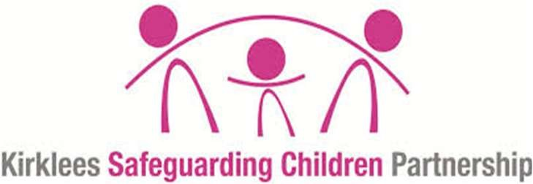
Strategy Discussion
Following areas must be discussed
1
. Is the Child
over the age of
10
?
2
. Are there are
criminal proceedings?
(
Child must be over
the age of 10)
Yes
No
Child must
have a YOT
representative
. Are there
3
multiple
victims and /
or
perpetrators?
Yes

Yes

No
No
The 1st
interview must
be conducted
by the police
A strategic management
group must be formed to
co-ordinate the case and
the complex / organised
abuse procedure must
be followed
. Are there
4
ongoing risks
to other
children?
Yes
No
A multi-agency
risk meeting
must be held.
This is in
addition to the
strategy meeting
This meeting must produce a risk management
plan that clearly outlines the accommodation
and education arrangements for the child/ren
(
both victim/s and perpetrator/s).
The need for specialist assessment must be
considered and commissioned where
appropriate. What services are appropriate
and will be provided
Notification to
the KSCP as a
serious incident
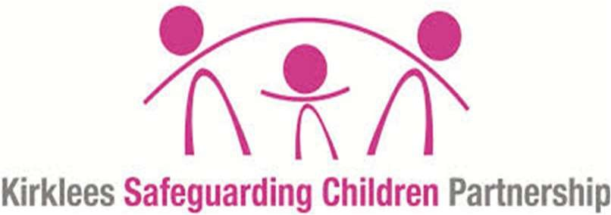

Assessment guidance
- Need for separate social workers for victim and perpetrator, even if in the same household
All Assessments should include:
- Details of the incident/s (including impact on victim/s, the context of abusive behaviours, age of victim/s, nature of the relationship between the children / young people involved.
- Child and young person’s development, family and social circumstances.
- Whether the “perpetrator” child / young person acknowledges the alleged behaviour.
- Whether there are grounds to suspect that the “perpetrator” child / young person has been abused or there are adults involved in the development of the harmful sexual behaviour.
- Details of previous incident/s.
- Assessment of child’s need and the need for any specialist assessments (including capacity / learning disability).
- Safety of other young people including a Risk management plan for school and one for home.
- Accommodation and Education arrangements.
- What services need to be provided.

A continuum of children and young people’s sexual behaviours
(Hackett 2010)
Simon Hackett (2010) has proposed a continuum model to demonstrate the range of sexual behaviours presented by children and young people, from those that are normal, to those that are highly deviant:

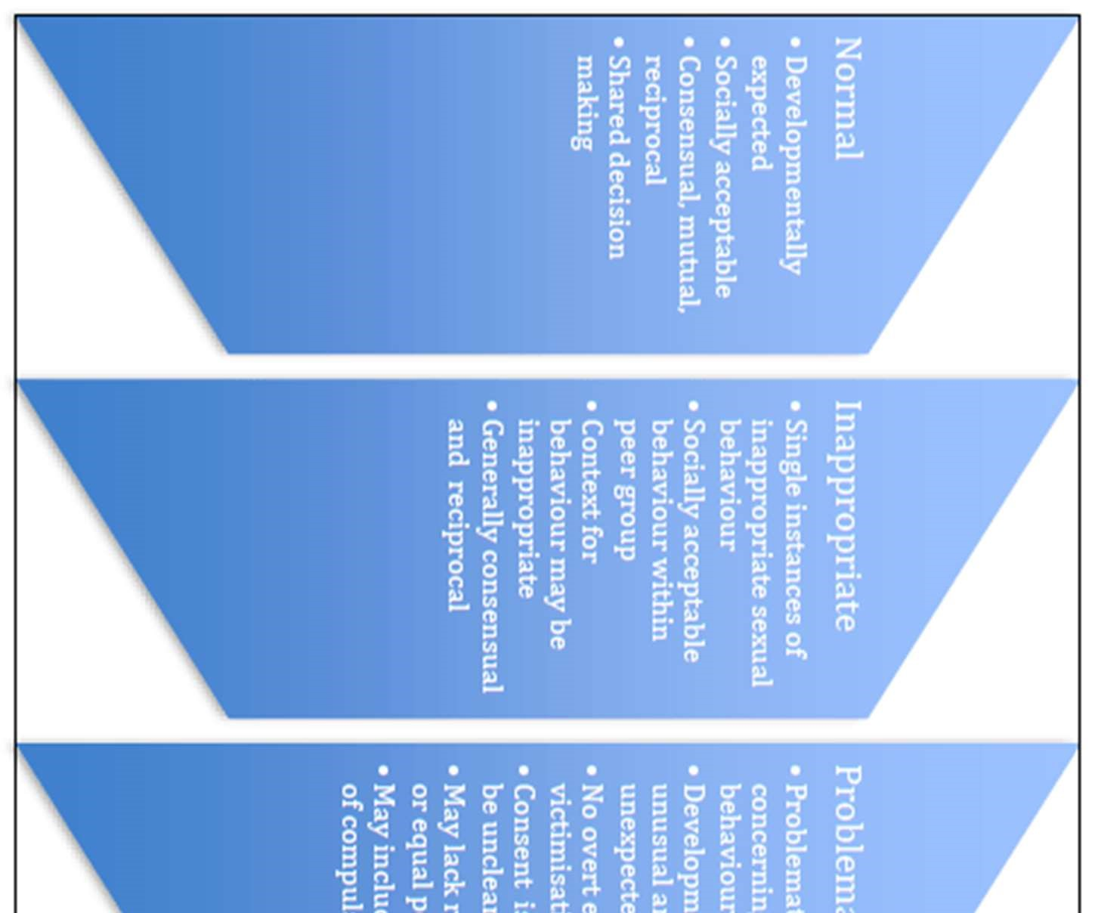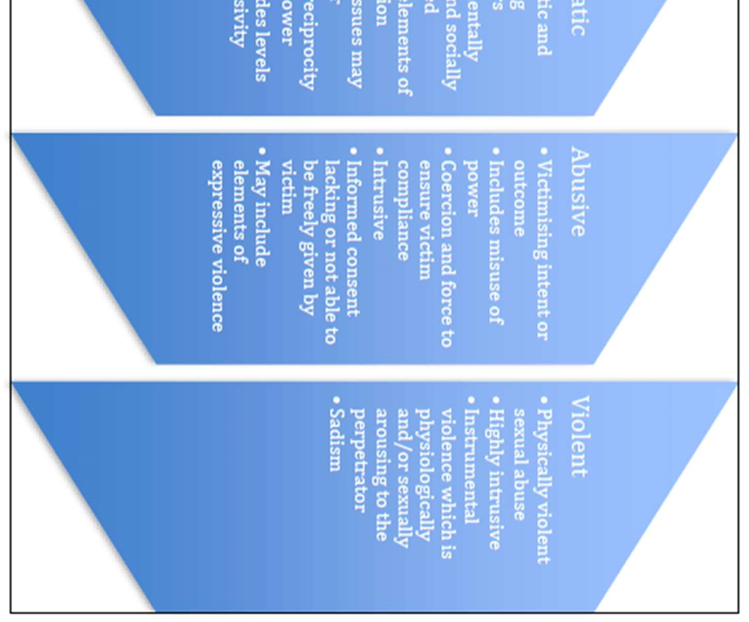

Appendix 8

Radicalisation Response Checklist

Summary of in-school procedures to follow where there are potential radicalisation concerns about a child/member of staff.
Further information and relevant guidance documents referred to, are available electronically from For more information about Prevent in Kirklees, including referral forms and project examples please visit the Kirklees Prevent https://www.kirklees.gov.uk/beta/community-safety-partners/prevent.aspx or contact the hub via 01924 483747 Anycomms “Prevent Referral”.

Showing sympathy for extremist causes.
Glorifying violence.
Evidence of possessing illegal or extremist
literature/videos.
Advocating messages of an extremist
Nature or hate, similar to extreme
Organisations e.g. Muslims Against Crusades or EDL.
Significant changes in behaviour, e.g. dress, social
groups, interests.
Any member of staff of staff
with concerns should make a
clear written record as per the
school’s safeguarding policy.

Speak to the school
designated safeguarding lead
The school designated safeguarding lead should explore the concerns and context and
discuss the concerns with the student and their parents in order to determine if a referral is
appropriate
If the individual is
an imminent threat
of harm to others

Contact the police
on 999

If not a PREVENT
concern

Make a referral to
Kirklees Duty and
Advice Team for all
other Safeguarding
concerns on
01484 414960

DSL agrees the
concern is
PREVENT
related

DSL submits a
referral via
AnyComms
Referral is screened by
the Kirklees PREVENT
Team, initial advice
offered and Kirklees
PREVENT process

Appendix 9

Missing from School Response Checklist
Referral pathway for reporting pupils missing / absconded during the school day.
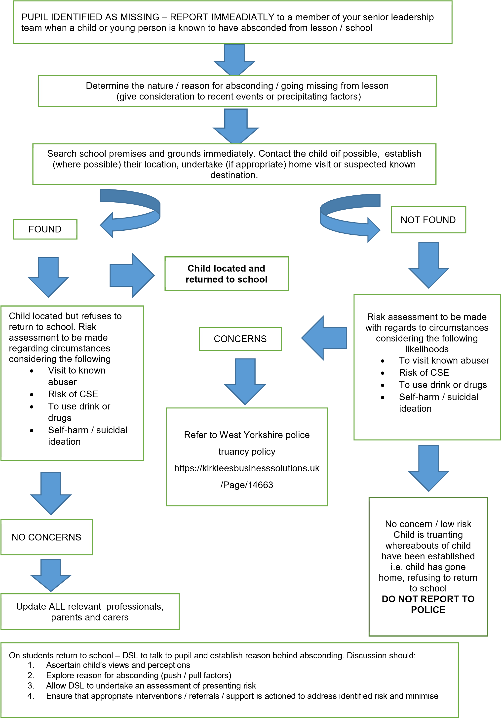

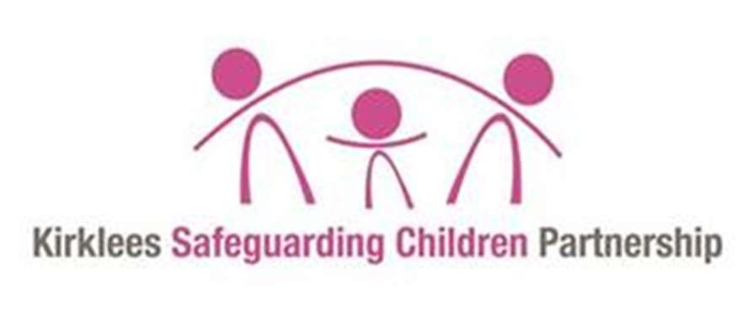
Appendix 11

Early Support Multi Agency Panel Process

Conversation between
referrer and Early
Support Team Leader
Lead agency
determined
Request for service using
Early Support referral sent
to Inbox
Details of case
entered onto panel
data base
Single agency/ area-based services
struggling to meet a Child/Young
Persons needs triggers the
commencement of process once consent
is gained from the family
Panel agenda created and
sent with referral to all
panel members
Panel members search
agency records gather
information to share at panel
Panel meeting discuss
the referral and
information shared by
members
Panel keep the case on the
agenda until informed that a
lead professional has been
allocated

Lead agency allocate the
case to a lead
professional
Case removed from
panel minutes
Lead professional
coordinates support
through TAF process
Once TAF satisfied the work
with family is completed, case
returned to panel for closure
Case closure form
completed, and case put on
agenda for final check with
panel before closure
Case closed if all panel members
satisfied no more work is required

Kirklees Council Model Safeguarding and Child Protection Policy 2022-23 59

This model school safeguarding and child protection policy was developed and produced in partnership with the following schools and agencies:

- Kirklees Education Safeguarding Service
- Kirklees Safeguarding Children’s Partnership
- Kirklees Children & Families - Early Support
- Kirklees Children & Families - Early Learning
- Kirklees Duty & Advice (CSC)
- Woodley School & College
- Newsome High School
- Howard Park Community School
- BBG Academy (The Rodillian Multi Academy Trust)
- Leeds City Council

Published August 2019
Updated August 2020
Updated August 2021 Updated August 2022

Kirklees Council Model Safeguarding and Child Protection Policy 2022-23 60

