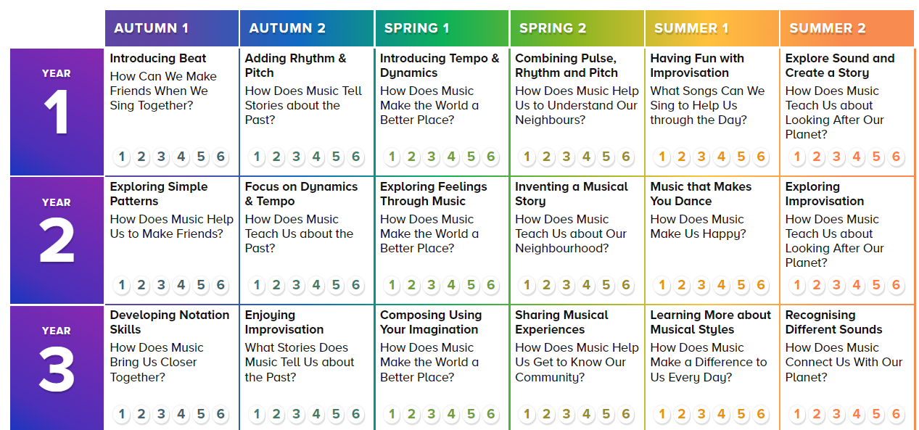
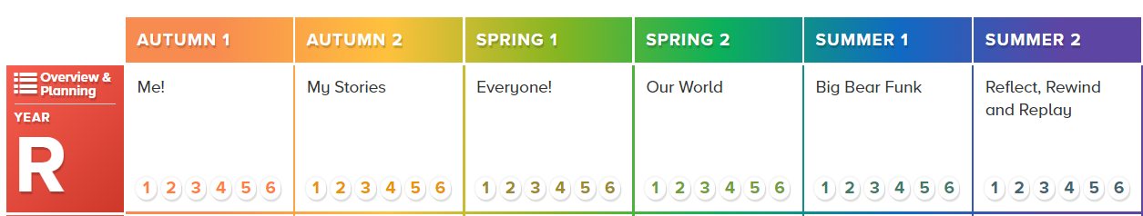
Pentland Infant & Nursery Long Term Plan Music- following Charanga planning

